The Project Gutenberg eBook of Hand-Loom Weaving, by Mattie Phipps Todd

The Project Gutenberg eBook, Hand-Loom Weaving, by Mattie Phipps Todd
This eBook is for the use of anyone anywhere at no cost and with
almost no restrictions whatsoever. You may copy it, give it away or
re-use it under the terms of the Project Gutenberg License included
with this eBook or online at www.gutenberg.org
Title: Hand-Loom Weaving
A Manual for School and Home
Author: Mattie Phipps Todd
Release Date: March 13, 2010 [eBook #31630]
Language: English
Character set encoding: ISO-8859-1
***START OF THE PROJECT GUTENBERG EBOOK HAND-LOOM WEAVING***

E-text prepared by Geetu Melwani, Stephen Hope, Josephine Paolucci,
and the Project Gutenberg Online Distributed Proofreading Team
(http://www.pgdp.net)
from digital material generously made available by the
University of Georgia Libraries
(http://www.libs.uga.edu/)

Note: | Images of the original pages are available through the collection of Facsimile Books & Other Digitally Enhanced Works, The University Of Georgia Libraries. See http://fax.libs.uga.edu/T848xT7/

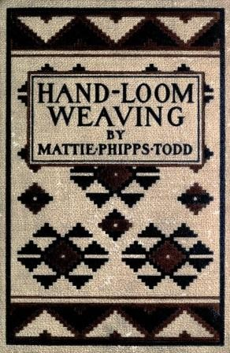

HAND-LOOM WEAVING

A MANUAL
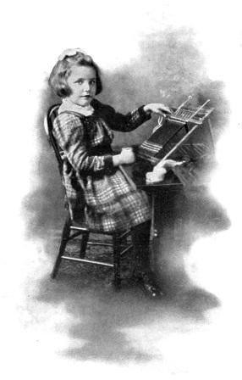 Weaving on a Hand Loom
Showing the necessary positions. The rug the little girl is weaving is made of heavy carpet wool. The body of the rug is golden brown, with stripes of deep blue and green, separated by narrow stripes of white

HAND-LOOM WEAVING

A Manual for School and Home

By

Mattie Phipps Todd

Of the Motley School, Minneapolis, Minn.

With an Introduction by

Alice W. Cooley

Formerly Supervisor of Primary Schools, Minneapolis, Minn.

With Fifty-seven Illustrations
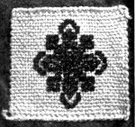
Rand, McNally & Company
Educational Publishers
Chicago New York London
Copyright, 1902,
By Mattie Phipps Todd

[Pg 5]

The Table of Contents

The Table of Contents
 |  | PAGE
An Introduction. | By Alice W. Cooley | 7
Chapter One. | The Primitive Loom | 13
Chapter Two. | A Chat on Weaving | 22
Chapter Three. | First Steps in Weaving | 30
Chapter Four. | Methods of Stringing Warp | 42
Chapter Five. | Materials | 51
Chapter Six. | Directions for Dyeing | 58
Chapter Seven. | Methods of Splicing Materials for Weaving | 83
Chapter Eight. | Wool and Silkoline Rugs or Mats | 86
Chapter Nine. | Hammocks | 93
Chapter Ten. | Face and Dish Cloths and Bath Rugs | 99
Chapter Eleven. | Raffia Mats | 101
Chapter Twelve. | Oriental Rugs | 122
Chapter Thirteen. | Navajo Blankets | 135
Chapter Fourteen. | Songs, Games, and Stories | 143
Chapter Fifteen. | A List of Helpful Books and Magazine Articles | 153
The Index |  | 159

[Pg 6]
The highest
aim of art is
to make some
useful thing
beautiful.
Kenyon Cox.

[Pg 7]

An Introduction
For many years we, the teachers of the United States assembled in village, city, State, and national conventions, have recited our creed and chanted it in all keys.

Our creed
We believe that man is a trinity, three in one—head, heart, and hand, one soul made manifest; we believe that this union is vital and indissoluble, since "what God hath joined together" may not be rent asunder; we believe that this three-fold man, being "put to school" on earth to grow, may devise and bring to successful issue no scheme of education that is out of harmony with the plan of the Creator.
Congratulating ourselves upon our ready and distinct utterance of this lofty thought, we have calmly returned to our man-devised book-schools for the acquisition of knowledge, in order to forward some plan for the accumulation of more knowledge.

Deeds, not words, are now necessary
But "wisdom lingered"! Here and there voices were raised that would not be silenced: "You sang your beautiful song; what are you going to do about it?" In the words of John[Pg 8] Stuart Mill, "It is now time to assert in deeds, since the power of words is well-nigh exhausted."
Investigators, studying this union of head and hand from the physiological side, hurled truths at us that startled us from our lethargy.

Physiological truths
Every stimulus poured into nerve cells through the avenues of the senses tends to pass out in motor action, which causes muscular movement. In every idea are vitally united the impression and the tendency to expression in action. The nervous system consists of the fibres which carry currents inward, the organs of central redirection, and the fibres which carry them outward—sensation, direction, action. Since control means mental direction of this involuntary discharge of energy (directed muscular movement), control of the muscles means development of will as well as of skill. To prevent or cut off the natural outflow of nervous energy results in fatigue and diseased nerves. Unrestrained and uncontrolled expenditure of nervous energy results in lawlessness and weakened will.
Men of science said: "These are facts about man. What account have you made of them in your elaborate system for educating him?"[Pg 9]
Students of sociological and economic problems called out to us as the teachers of men:

Labor must be respected
These great problems concerning the relation of labor and capital (the brotherhood of man) will never be solved until there is greater respect for labor; greater appreciation of the value of the products of labor; until there is more joy to the worker in his labor, which should be the expression through his hand, of the thought of his head, and the feeling of his heart; until labor is seen in its true light, as service; until the man with money as well as the man without learns through experience to respect and appreciate labor and its products. "We absorb only so much as we can interpret in terms of our own active experience."
What contributions are our schools making to the bettering of social and industrial conditions?
Philosopher and poet—thinker and seer—send their message:
"That life is wisest spent
Where the strong, working hand
Makes strong the working brain."
To create, to make something, is the instinct of divinity in humanity, the power that crowns man as divine.[Pg 10]
"It is his impulse to create
Should gladden thee."

The will to do
The practical business man thunders his protest at us against the inefficiency of the man with only the knowledge-stored brain. He says: We must have men that can will to do, and then do something, not merely men that can think of things "'twere good to do." Our public schools must train men and women to go out and take their place with the workers of the world, to do something well and effectively.

Systematic hand-training the work of to-day
At last we are awake, and throughout the country we are trying to heed these calls, and to revive our own weakened thought by action, singing our creed in deeds. Upon the foundations laid by Friedrich Froebel and his students in the kindergarten, we are trying to build up a course in systematic hand-training, through the primary, to intermediate and grammar grades, and thence to manual training in the high schools. What to do and how to do it has now become the practical problem of the day. Everywhere the wide-awake primary teacher is sharing her thought and experience with her co-workers.
For little children, the what must utilize material suitable for little fingers, and tools[Pg 11] must be large. The finished product should belong to the maker, or be made by him as a service rendered to others; the result should also be worthy of keeping or giving, from the view-points of both beauty and utility.
Another important factor is the adaptation to present public-schoolroom conditions, and to present public-school treasury conditions.

Weaving the best hand work for primary schools
More thoughtful study has led to the abandonment of the old-time sewing and fine handwork in kindergarten and primary school. In its place we find the weaving of useful and beautiful articles, out of various available materials, and with simple, primitive tools—allowing always for much and varied use of the great tools, the fingers.
It is interesting to note that teachers in all parts of the country, working independently of each other, have come to practically the same conclusions, viz., that under present conditions, weaving seems the best basis for a systematic course in industrial work that shall train head and heart as well as hand. It is also of great interest to remember that the signboards along the pathway of race development, by means of work, exchange of labor and its products, all point to this idea as the entering gateway.[Pg 12] Weaving is the first industry of all primitive peoples.

This manual the result of study and experience
Being practically agreed as to what shall be the first industrial work in the primary school, the next great question is the how. With large numbers of little children in her own schoolroom, the author of this manual has long sought a satisfactory answer. Believing that the results of her study and experience will be helpful to others in suggesting possibilities, and in stimulating thought, as well as in practical teaching and time-saving, she sends forth this little book with the earnest hope that it may in these ways be of real service.
Alice W. Cooley,
Critic Teacher and Instructor,
University of North Dakota.
August 1st, 1902.

[Pg 13]

Hand-Loom Weaving

Chapter One

THE PRIMITIVE LOOM

History of weaving
Weaving, the oldest of the industrial arts, dates back so far that no one can say when or where it had its beginning. We read in Genesis iii, 21, that when Adam was driven from the Garden of Eden he wore a coat of skin; but, not long after, according to Professor Hurwitz, the descendants of Adam wore an upper garment called the simla, which consisted of a piece of cloth about six yards long and two or three wide, greatly resembling a blanket (Ashenhurst). This might have been woven from vegetable fibres, perhaps from wool, but in what manner we do not know. The warp and woof of linen and woolen garments is mentioned in Leviticus xiii, 47, 48.

Dyeing
Spinning and weaving have been practised by the Chinese, Hindoos, and Egyptians for thousands of years and carried by them to great proficiency. The Israelites were probably familiar with the art of weaving[Pg 14] before their sojourn in Egypt, but it was there that they attained the skill which enabled them to execute the hangings in the Tabernacle. Joseph's "coat of many colors" is a proof that dyeing existed at a very early period, and the eloquent writings of Ezekiel tell us of the beautiful colored cloths of Tyre and Damascus.

Migration of weaving
From the ancient world the art of weaving passed through Europe and became known in England after the Roman conquest. No doubt primitive weaving with vegetable fibres, and perhaps with wool, was known in a very crude way before that time. How the art developed, and how improvement followed improvement, makes very interesting reading for the student of textile fabrics.

Weaving as the first industrial art
We know that weaving is the first industrial art practised by primitive peoples, from the fact that it is found among the savages of Central Africa (Park) and the islands of the sea. "Clavigero, in his history of Mexico, shows that on the conquest of that country, weaving was found to be practised by the natives." (Ashenhurst.)

Egyptian loom

Method of pushing the woof

Hindoo loom
The Egyptians are supposed to have been inventors of the loom. There were two kinds in use, one horizontal and the other[Pg 15] perpendicular. Instead of a shuttle they used a stick with a hook at one end, which was used also as a batten. Herodotus says that it was the practice of the Egyptians to push the woof downwards, and this method is pictured in many paintings; but one representation found at Thebes shows a man pushing it upwards. The former method is, I believe, the one generally used by all nations, and it certainly seems the easier way. Martin's description of a Hindoo loom in his "Circle of the Mechanical Arts" is interesting: "The loom consists merely of two bamboo rollers, one for the warp and the other for the web, and a pair of gears. The shuttle performs the double office of shuttle and batten, and for this purpose is made like a huge netting needle, and of a length somewhat exceeding the breadth of the cloth. This apparatus the weaver carries to a tree, under which he digs a hole large enough to contain his legs and the lower part of the gear. He then stretches his warp by fastening his bamboo rollers, at a due distance from each other on the turf, by wooden pins. The balance of the gear he fastens to some convenient branch of the tree over his head. Two loops underneath the gear, in which he inserts his great toes, serve instead[Pg 16] of treadles, and his long shuttle, which also performs the office of batten, draws the weft through the warp, and afterwards strikes it up close to the web."

Crude implements used by primitive peoples

Patience and dexterity necessary
Ashenhurst says: "It is very evident that the implements used, not only by the early Egyptians, but by other contemporaneous nations, and even by the Hindoos at the present time, were of the rudest possible character, and nothing but the most exemplary patience, dexterity, and great delicacy of hand, acquired by long traditionary habit, can account for the extraordinary beauty and fineness of their textile productions." This exemplary patience, dexterity, and great delicacy of hand is exactly what we claim that weaving develops in our children to-day.

Primitive loom in the public schools

Its disadvantages
The primitive loom, as it is made for use in the public schools, is familiar to almost every teacher. It consists of a wooden frame, in the two ends of which are fastened brads at intervals of half an inch. The warp is strung around these brads. There is no variation either in the size of the rug or in the width of the warp to afford opportunity for different materials. This is a decided objection, as a new frame has to be made every time a change is desired. The first difficulty encountered is the drawing in of the sides of[Pg 17] the rug, which is almost impossible to avoid, even with the utmost care. Photographs of work in the leading educational magazines, as well as samples of teachers' work, all show the same defect. The Indians obviate this difficulty by twisting two stout cords in the edge of the woof during the process of weaving. (See illustration on page 135.) In one school, where the work in this respect was fairly well done, the teacher was asked how she accomplished the result. Her reply was, "Oh, I make them pull it out every time it draws." Poor, patient little fingers! One can imagine the thoughts which were woven into that imperfect rug by the discouraged little worker. Another disadvantage of the primitive loom is that the child must bend over it while weaving, and if, by chance, he turns it over to examine the other side of the work, the brads are apt to leave an unsightly impression on the desk.

Success in doing
One of Froebel's fundamental principles is that a child should never be allowed to fail—that his work should be so adapted that he will succeed every time, and that he should be led step by step as his power grows, to something more difficult.
"One thing is forever good,
That one thing is success."
[Pg 18]
We have all experienced the joy of success in one way and another. Let us help the children to have the same experience.

Idea of the "new education"

Small classes

Public school conditions
The idea of the "new education" is that the child should work out his own salvation—that having wrestled with the difficulties involved in weaving on the primitive loom, he should proceed not only to invent, but to construct a newer and more improved loom. In model schools, where the classes are limited to ten, or sometimes fewer children, with one teacher and several assistants, this idea, if carried out, is ideal, and perhaps practical. But what shall be said of the public-school teacher who has fifty children and no assistants; or, which is even more objectionable, and which is the case in many of our crowded schools, what of the teacher with two sessions of fifty children each? It was the effort to solve a problem of this kind that led to the invention of the Todd adjustable hand loom.
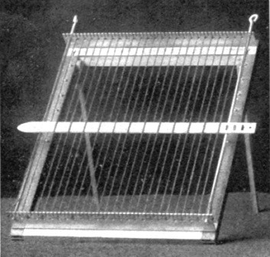 The Todd adjustable hand loom, Style b

Description of the Todd loom

The needle

Finishing the work

Removing the work
The full size of the loom is 10 × 13 inches, upon which a rug 9 × 12 inches can be woven. It is made adjustable to innumerable smaller square and oblong sizes, by two devices. To regulate the length, the head piece, which is movable, can be let down on brass buttons, which are disposed along the sides at[Pg 19] intervals of an inch. Perforations are placed half an inch apart in the head and foot pieces so that the side rods can be moved inward to regulate the width. They also insure straight edges, since the woof threads are passed around them as the work progresses. The rods also serve another important function as fulcrums upon which the needle may be pressed up and down, so that it passes more easily over and under the successive warp strings. The notches are one-sixteenth inch and the teeth one-eighth inch apart, giving opportunity for warp one-half, three-eighths, and three-sixteenths inches wide. The loom has an easel support, so that the pupil need not bend over it—an important consideration in school classes, and in home work as well. This support makes it possible to use the loom for an easel in the painting lessons, by resting a piece of pasteboard against it. The needle, which is longer than the warp is wide, serves also as a heddle in pressing the woof[Pg 20] threads together evenly. It is furnished with an eye for worsted, chenille, carpet ravelings, or rope silk, and three slits for rags. To thread the needle with rags, pass the strip up and down through the slits and back again under the strip through the first slit. This binds the strip securely. In finishing the work weave the last few woof threads with a large tape needle, putting it up and down, over one thread at a time, as you would sew on canvas. It has been found desirable with children to push about an inch of woof threads close to the head piece and then fill in the space. Care should be taken not to pull the woof too tight. If these directions are followed and the warp is strung correctly the strings will not slip out of the notches. In adjusting the loom it will be found that the width from rod to rod is a little more than is required. For instance, for a rug nine inches wide, the width from rod to rod will be about nine and one-half inches. This is to allow for the[Pg 21] springing together when the work is finished. To remove it from the loom, pull the rods gently upward and out. Then lift the warp strings out of the notches.
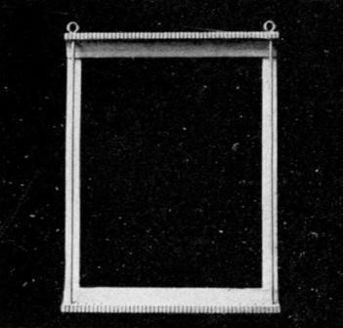 The Todd adjustable hand loom, Style a

Use of the primitive loom
The primitive loom can be used by following these same directions, but the work will, of course, be limited.

For school and home work
While a great deal of the work is intended for the schoolroom, many suggestions are given for home weaving, in making various articles for birthday and holiday gifts.

[Pg 22]

Chapter Two

A CHAT ON WEAVING

Weaving defined

Weaving trains both hands

The three-fold development
Weaving is the art of interlacing threads, yarns, filaments, or strips of different material, so as to form a cloth or fabric. It is an ideal occupation, not only for little children, but for older ones as well, affording admirable opportunities for the development of head, hand, and heart. It trains both hands in deftness and proves a delight to the left-handed child, who for the joy of using his left hand again, will plod patiently across with the right. The fat little hands soon learn to grasp the large needle, and the nerves and muscles of both hand and arm are strengthened by daily use. Both hand and eye are trained in accuracy, and the training in patience, perseverance, industry, economy in the use of materials, perception, concentration, dexterity, and self-reliance cannot be overestimated. The heart, too, has its part in the joy of giving to others, for the children are encouraged to make little gifts for the home. A consciousness of power comes, also, with experience; and a[Pg 23] sense of self-respect arises when the child realizes that he is of some use in the world.

Knowledge of principles necessary
Lois Bates, in her "Kindergarten Guide," says that "in the manufacturing districts of England great numbers of the children who pass through the elementary schools are employed in mills where weaving is carried on, or enter textile schools to learn designing in cloth. If this occupation of mat-weaving could be continued until the children had a thorough knowledge of its principles, how much intelligence might be brought to bear on the actual weaving and how much more pleasure might the worker draw from labor that is often looked upon as so much mechanical drudgery!" The keynote for this is the thorough knowledge which is necessary, whether or not our children are to enter textile schools. Whatever they do, let them do it thoroughly. It should always be a question of quality, not quantity.

Simple weaving the first essential

Mats as a preparation for loom weaving

Slat interlacing and splint work lead to basketry
For this reason I have taken up, quite at length, the subject of first steps in weaving, believing that children should be kept at simple weaving until they understand the principles thoroughly. The felt and paper mats prepare the way for loom-weaving; the free paper weaving, and the slats and splints for basketry. A few suggestions on the use[Pg 24] of the slats and splints have been given for two reasons: First, for the training which they afford in dexterity and great delicacy of touch, to say nothing of exemplary patience; and second, because the preliminary training for basketry should be given in the lower primary grades. The time necessary to train clumsy fingers can hardly be taken from the regular work in grades where basketry is a prescribed course.
"Skill in the fundamental methods of weaving is essential even as the fingers must be trained in music before the soul of the musician can find its expression. Make good baskets first, simple in shape, strong in texture, suited to the purpose for which they are intended; unconsciously they will grow beautiful. The most intricate basket will fail in its purpose if the joinings are careless or flaws in workmanship permitted. If originality is within the weaver, it will find its expression, once the principles of weaving are second nature." (C. S. Coles.) This is also true of rug and mat weaving, for the aim of all training should be to bring out the best there is in a child.

"Devotedness to duty"
"The longer on this earth we live
And weigh the various qualities of men,
The more we feel the high, stern-featured beauty
Of plain devotedness to duty;
[Pg 25]Steadfast and still, nor paid with mortal praise,
But finding amplest recompense
For life's ungarlanded expense
In work done squarely and unwasted days."
—James Russell Lowell.

Weaving the foundation for designing

Honest work begets sympathy with labor

Interdependence in life
The "Kraus-Boelte Guide" has some good suggestions with regard to the value of paper mat weaving, in number training, and for following certain formulæ which will lead ultimately to invention. Mme. Kraus-Boelte says: "Weaving leads to independent effort and offers the greatest scope for future technical work, for it lays the foundation for designing. Even though it may not fan into flame a latent spark of genius, this means of occupation at least tends to show the value of honest labor." The child not only recognizes the value in honest labor, but his sympathy with all labor is aroused through his own efforts and through the stories told of weavers in all lands. He realizes, also, although in a limited way, the interdependence of the whole world. If the sun did not shine, and the rain fall, there would be no grass. If there were no grass, what would the sheep do? If the sheep did not give any wool, what would the weaver do? If the weaver could not weave, what would we do for clothes? Little children are always delighted to go back to the[Pg 26] beginning of things. Oh, the joy of looking back on one's school days! As Friedrich Richter has truly said, "Recollection is the only paradise from which no man can be driven."

Some difficulties

A bit of experience

One solution

Community feeling continued
One important thought in this whole subject is that the work should be so arranged as not to add any additional burden to the already crowded life of the teacher. It is a lamentable fact that we have overcrowded rooms, and only one pair of hands to do all that has to be done. Perhaps a bit of the author's own experience will be of some assistance. After looking the subject squarely in the face and considering it on all sides, the writer came to the conclusion that it would be an impossibility to do all the work alone. So some helpers were called from the pupils of the higher grades, and the request met such a hearty response that it was wondered why it had not been tried before. As it is now arranged the older girls come in before school and at recess. They wind worsted, correct any knitting that may be wrong, start new spools, string looms, cut material for rugs, water plants, keep the closets where the materials are stored in order, and do many other things which relieve in a great measure the burden[Pg 27] of detail. When it is possible, the teacher should choose girls who have a sister or brother in the room, because their interest is stronger and more lasting. Of course, some training is necessary, but the result compensates for the trouble. Sometimes the work in other grades can be so planned that the children can make paper mats, etc., for use in the first grade. The beautiful community feeling begun in the kindergarten can thus be continued in the public school. The time will come when boys and girls in the higher grades will design patterns for the younger children to weave.

Nature knows no hurry
Take plenty of time in the first part of the year to teach the children to work well. "Time is nothing when power is growing." There are some children who learn faster than others and they are always delighted to go about the room and help the slower ones. It will sometimes be found that they know just how to explain a difficult point—perhaps because they have just conquered it themselves.
A child's work should be suited to his capacity, without regard to grade

Train the individual
No work has been specified as suited to any particular grade. It should depend entirely upon the children. While, for convenience, courses in industrial training are planned, advising certain lines of work which experience has proved the best for[Pg 28] first, second, or third grade, there are in every school, certain children who have more manual than mental ability. These are left behind as the more favored ones are promoted, and because a certain course has been recommended for that particular grade, they must, perforce, do it all over again. Instead of bringing out the best in these less fortunate ones, and developing and strengthening their minds through the hand by offering something not only new and interesting, but which presents new difficulties to conquer, we stunt their growth by giving them the same baby work term after term. It is time that earnest teachers considered this important question. Let us give up training the mass and begin to train the individual. Through our interest in them they may find their life work. If a child in the first grade is prepared to do any industrial work of a higher grade, no matter how dull he may otherwise be, by all means let him do it. It is his way of expressing what lies within him. Not only will his hand and mind be trained thereby, but his heart will be filled with the joy that always comes through achievement.

Value of hand training
If you would develop morality in a child, train him to work

Making citizens
Hand training has been found to be of great value in all other work. The children[Pg 29] are brighter, and seem better able to grasp an idea. The slow children are also stimulated, and in doing the simple work well are preparing for that which is more difficult. Impression and expression should go hand in hand. We know nothing of "the bad boy," now that we have found something for his restless fingers to do. "The habit of methodical work is the basis of all ethics." In teaching children to do their best, we are training citizens. Some one has facetiously remarked that, "In the making of a good citizen it is necessary to catch your citizen early." We cannot get hold of the anarchists, but we can get hold of their children, and in the training of them to work lies their salvation. Formation is better than reformation.

Formation, not reformation

New applications for old teachings
Verily, there is nothing new under the sun. We hie ourselves to the summer schools, and return laden with new ideas—when lo! it dawns upon us that all we have done during the hot days has been to make a new application of what Froebel taught the world before we were born. So in this introduction, an old story has been retold, but I hope that it will come with a new meaning to my fellow teachers.

[Pg 30]

Chapter Three

FIRST STEPS IN WEAVING

Felt mats and slats

Demonstration cards and diagrams
The principles of weaving are very easily learned with felt mats and slats. One-half a yard of felt two yards wide will make thirty-six mats six inches square. These are very durable, and can be used year after year, if protected from moth during the summer. Some prefer leather or oil-cloth mats, backed with heavy unbleached muslin, but they are more expensive, and not so pleasant to work with as the soft wool. The slats, which should be at least one-half an inch wide, can be obtained at any kindergarten supply store. Buy the uncolored slats and dye them yourself. Dark green mats, woven with deep red slats, are pretty. The slats are easier to handle if they are soaked and cut the required length before dyeing. When the six-inch mats are cut, allow a three-quarter-inch margin on all sides. Measure the mat for one-half-inch strips, of which there will be nine, and mark by snapping a chalked string upon the mat. Double it with chalked lines outside and commence to cut from the[Pg 31] center; then open and finish cutting to the margin. It would be better for very little children if the strips and slats could be one inch wide. In this case the mats would, of course, be larger, and it might be necessary to have the slats made to order. The slats should be kept in little bundles containing the required number, and secured by rubber bands. If one could have plenty of time and material it would be a good plan to have several sets of mats of different sizes, so that the children would not always be confined to one number and its combinations in a certain set of patterns—in this case, nine—but have the pleasure which comes from variety. Demonstration cards and diagrams for weaving can be obtained at the kindergarten and school-supply stores. An illustration of an excellent demonstration frame can be seen in the "Kindergarten Guide," by Lois Bates. Sample mats can be woven by the older children from the designs in any of the "Guides," and given to the smaller children to copy.

Purpose of practice mats

Do not deceive the child
When the purpose of these practice mats is understood there can be no objection to them on the ground that the work is destroyed by pulling out the slats each time. It is not an unusual thing to see in schools,[Pg 32] and even in kindergartens, faithful and conscientious teachers remaining after hours to pull out the slats, on the principle, perhaps, that what the children do not see will not affect their development, and the innocent little bundles are given out again on the morrow, only to undergo the same experience at night. One wonders sometimes if this is possibly within the definition of deception. "We mount to the summit, round by round," and when the children understand that in doing the work with the slats well, they are only learning how, and that each successful attempt brings the delightful day nearer when they may have a loom to work upon, they are perfectly satisfied.

Long slat weaving
When the children have learned to weave the small mats, further practice can be had by weaving long slats into a warp of cord on the loom. It is better to conquer the mystery of "over and under" in this way than to undo the work and wear out the material after making a mistake.

Paper mats
Many teachers prefer to make the practice mats of paper because they are cheaper. Heavy paper, in desirable colors, can be obtained at the wholesale paper houses, and for a small sum can be cut in squares of any required size. Mats can be made more[Pg 33] durable by pasting them on heavy muslin before cutting. In many schools children in grades above the entering room prepare their own mats by measuring with tablets or rulers and then drawing and cutting on the lines. When they have learned to do them well, let each child make one for the entering room. Nothing strengthens the community feeling so much in a school as to encourage the older pupils to help the younger.

Mat weaving in the kindergarten
The mat-weaving, as it is done in the kindergarten, is very beautiful and fascinating work. The mats can be obtained in any size and any width of strips at the supply stores. The weaving is done with a long steel needle which has a spring at one end to hold the strip. After preliminary work with the felt mats and slats the children find themselves able to weave quite independently, particularly if demonstration cards or sample mats are placed before the class. An infinite variety of patterns, which later will be useful in wool-weaving, can be found in the "Kindergarten Guides." In weaving patterns having a center, it is better to weave two strips at once, pushing one to the top and one to the bottom of the mat. The old numbers of the Godey and Peterson magazines[Pg 34] have patterns for Berlin wool and bead work which can be used for the paper mats with good effect. Mrs. Kate Douglas Wiggin (Mrs. Riggs) has some good suggestions for invention in weaving, in her "Republic of Childhood" (Occupations). The value of weaving in number work is also admirably set forth in this book.

Gifts
At Christmas time many charming little gifts can be made of these mats. Sachet cases made of a six or eight inch square, with four corners folded to the center, are attractive. Inclose a square of wadding, in which a pinch of heliotrope or white rose perfume powder has been hidden, and fasten the corners together with a scrap picture of old Santa Claus.
Slat work is useful in learning the fundamental principles of weaving, although this work is more closely related to basket than to rug weaving. It is an excellent preparation for the free-paper weaving, and is also a step toward basket work.

Interlacing slats
In interlacing slats the mystery of "over and under" is solved and the dependence of one slat upon another in making a perfect whole is shown in a forcible way, particularly when the form falls to pieces in the attempt to lift it from the table. Edward Wiebe[Pg 35] says in his "Paradise of Childhood": "It was the one slat which, owing to its dereliction in performing its duty, destroyed the figure and prevented all the other slats from performing theirs." One experience of this kind will teach more than a thousand precepts. The geometrical forms learned in the sense-training lessons can be reproduced with the slats and will thus be impressed upon the mind during the period of busy work at the desk. A series of beautiful designs is published by E. Steiger, New York. Many designs may be grouped for decoration, and single symmetrical figures can be mounted upon heavy paper.

Free-paper weaving

Sequence
Free-paper weaving requires quite a little skill of hand and a great deal of patience before the child can achieve a successful result. Perhaps a few words regarding it, and information about a simple sequence of paper patterns, will not be out of place, since so many are to-day taking it up. Strips of manilla paper forty inches long and one inch wide are used. These are cut into strips eight inches, sixteen inches, twenty inches, and twenty-four inches in length. For the first pattern of the sequence take four strips eight inches long and double each one. Hold two of them side by side in the left hand, so[Pg 36] that the open ends of the outer strip are at the top while those of the other are at the bottom. With the right hand inclose the first strip in the left hand with one of the remaining double strips and pass the ends of the latter between the two ends of the second strip. Then hold the work in the right hand and proceed in the same way with the left hand. When both strips are in, draw them tight and they will be firmly woven. The ends can be cut in any way desired. These little forms can be used for bookmarks. They are very attractive when made in two tones of one color.
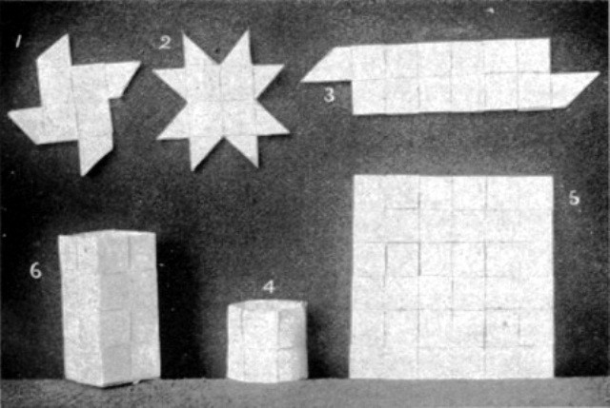 Sequence in paper weaving

Sequence weaving
The second pattern of the sequence is[Pg 37] made with sixteen-inch strips. The first part is woven like the bookmark. Four double strips now project from the square. Begin at the bottom and fold back the upper one of each of these double strips. As you do this you will find that you are weaving another square on top of the first one. To secure the last strip pass it under the square next to it and pull it through. You will now have eight single strips, two on each side. To form these into points for a star proceed as follows: Begin with the right-hand strip at the top and number all the strips from one to eight. Fold number one back toward the right, making at the fold a right-angled triangle. Fold the strip down again towards you, making another triangle which is folded back to the left on the first one. Slip the end of the strip under the square next to it and cut it off. Proceed in the same way with three, five, and seven. Then turn the form over and fold the strips two, four, six, and eight in the same way, cutting off the strips when finished. Many of these stars can be joined to make mats, baskets, picture frames, etc. They are pretty when made of gilt or colored paper for Christmas decorations.

Sequence weaving
Pattern number three, a bookmark, is made like the first, except that eight strips of[Pg 38] sixteen-inch length are used and the strips woven at right and left are finished as directed for the mat. Number four is another form like this, with the long ends back and front slipped through squares to form a napkin ring. Number five is a six-inch mat made of twelve twenty-inch strips. Weave six double strips left and right into two strips and then add four to make the square. To finish the edge cut off the under one of each double strip, fold the upper one over it and then slip it under the square which comes next, cutting it off even. Strips of felt can be woven in this way for table mats or holders.
The sixth pattern is a pencil holder or a basket, as you may wish. It may be round or square on the bottom—in the latter case the sides are creased to form a square prism. Double twelve twenty-four-inch strips, weave eight right and left into four; finish one long edge for the top of the basket as you did the edge for the mat. Bend in the form of a ring and slip the ends as you did for the napkin ring, cutting them off. To make the bottom, crease all the projecting ends in and weave together as you did the second part of number two only double, and fasten the strips on the outside of the basket. This[Pg 39] makes a good waste basket for the doll house. With a cover it would make a fine hamper for Miss Dolly's clothes.
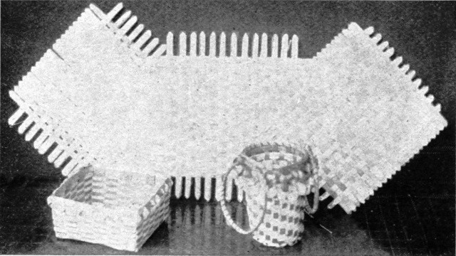 Examples of splint work

Weaving with splints
This free weaving leads directly to weaving with splints. These are much thinner than slats and can be obtained at the kindergarten supply stores. Many beautiful things can be made with splints. They are easily dyed at home and many pleasing combinations of color can be obtained in this way. Celluloid strips make beautiful boxes and baskets.

"Jacob's ladder"
A delightful exercise with the small children is the making of a "Jacob's ladder," or "Pussy-cat stairs," as they are often called. Fold a forty-inch strip of paper, one inch wide, so as to form a right-angle in the middle. Or, if a longer ladder be desired,[Pg 40] place one end of a forty-inch strip over the end of another one, at right angles, and fasten with a drop of paste. Fold from left to right, one strip upon the other, until you come to the end; then pull out, and behold the stairs! The fat and clumsy little fingers will work patiently a long time to achieve this charming result, and much skill of hand will be gained in the doing. Use colored paper for this whenever possible.
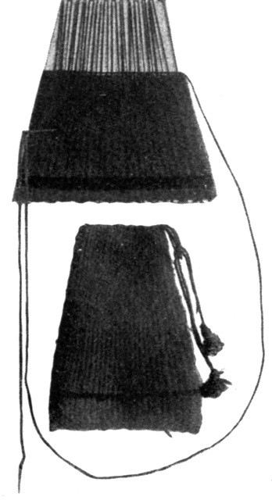 A skirt for winter
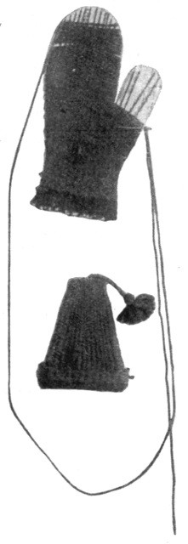 A mitten and a cap
The illustrations on this and on the following page show some fascinating work for little hands. The looms are made of heavy pasteboard cut in notches, in which the warp of the same[Pg 41] material as the woof is strung. Care should be taken to keep the warp straight, and to finish all the edges well. The articles in the illustrations were made by first-grade children in the Ericcson School, St. Paul, Minn.
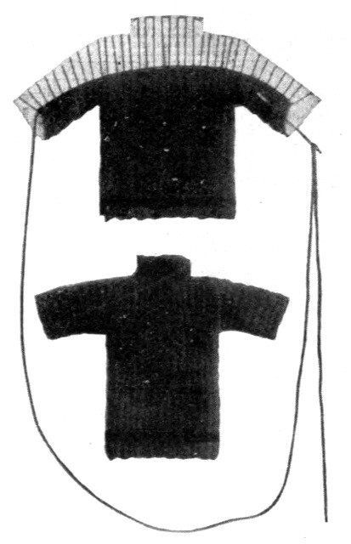 A sweater for the doll

[Pg 42]

Chapter Four

METHODS OF STRINGING WARP

Warp of three widths
The adjustable loom can be strung with warp of three widths, one-half inch, three-eighths inch, and three-sixteenths inch, thus giving opportunity for a variety of materials.
For heavy rags, candle wicking, etc., wind the warp strings around three teeth in the head and foot pieces. This will give a warp of one-half inch—that is, one-half inch from one string to the other.
For silk, silkoline, finer rags, carpet ravelings, double wool, etc., wind the warp strings around two teeth, thus making a warp of three-eighths inches.

Kindergarten patterns
For double wool, worsted, rope silk, chenille, or raffia, where one wishes to reproduce kindergarten designs, as in paper-weaving, place the warp strings around one tooth only. This makes a close warp of three-sixteenths inch, which helps to form the design with the woof threads. In this case the warp should be of the same material as the woof. In kindergarten patterns the woof threads[Pg 43] determine the color effect. It is better to have the children weave the pattern first with practice mats and slats, particularly if they have never had experience in the kindergarten. Suggestions for weaving kindergarten designs are given under the head of Raffia.

Plaids
For a plaid effect, string the warp at regular intervals, with different colors. Then weave the same colors at equal intervals to form the plaid. (See illustrations, pages 92, 98, and 101.) Shawls, carriage blankets, etc., woven in this way are very attractive.

Stripes
A striped warp is strung in the same way. (See illustrations, pages 101 and 117.) The stripes could be continued through the mat, if desired, by weaving only one color in the woof. By weaving two colors squares are obtained such as those seen in the corners.

Materials for warp
For weaving with carpet ravelings or rags, and sometimes double wool, where a plain effect is desired, the warp should be of common twine, as near the color of the work as possible. Carpet thread is good, especially for the double warp in Turkish rugs. Balls of warp string can be obtained at department stores. Oriental cord comes in several colors, and can be had at a few cents a ball at the notion and stationery counters in department stores.[Pg 44]

How to string a warp
The warp should always be one continuous string, and several inches should be left at each end in order to fasten securely when the work is finished. If preferred, the warp ends can be fastened before the weaving is commenced. Care should be taken to place the first and last strings of the warp directly over the rods, and, in weaving, to pass the woof threads entirely around the rods and strings to insure straight edges. The ends of wool warp threads should be wound in and out of the notches to the right and left of rods, to fasten them until the weaving is finished. It sometimes happens that little children, and more especially those who are blind, pull up the warp strings when near the end of the work. In such cases it is a good plan to pass a rubber band over the warp strings at the top of the loom and behind the bars, back of the head piece, making it set up close by putting it around one tooth at each end. In this way the warp strings cannot possibly slip out of the notches.

Splicing with a weaver's knot

A raffia warp
Some teachers splice the warp with a weaver's knot, an illustration of which can be seen in any large dictionary. The continuous string is to be preferred, however, as experience has proved that even a weaver's knot will sometimes fail to stand the stress[Pg 45] of weaving. It is very difficult to splice a warp of raffia. It is better to knot the warp threads in pairs (see directions, page 46), leaving two or three inches beyond the head and foot. These ends may be used for a fringe by tearing very fine, or they may be run down in the woven part with a darning needle, as rattan is run down in basket work.

To fasten wool or silk warp strings

When the warp is correct
When the weaving is done and the mat lifted from the loom, the ends of the wool warp strings can be run in along the sides with a tape needle. If the warp be of twine, it is better to tie the end to the next warp string and allow the fringe to cover the knot; or, as in the case of silkoline, the woof strips can be caught over the warp strings with silk of the same color in order to hide them. Only experience can teach the tightness with which a warp should be strung. Worsted, carpet thread and twine will stretch as the work progresses, and raffia will not. If the warp be too loose the work will be uneven and the strings will slip out of the notches. If it be too tight it will be difficult to finish the last two or three inches and the woof threads will look crowded. The best test is to place the hand upon the warp before commencing to weave. If it feels firm and does not push down too easily, but[Pg 46] springs slightly beneath the hand, it is probably correct.

To string a warp for fringe

To string the warp threads in pairs
Where the warp is of the same material as the woof and it is desired to extend it to form a fringe, it can be done in the following manner: After the loom is adjusted for the size required, cut the warp strings so as to allow two or three inches beyond the head and foot pieces. If you intend to knot the fringe in some fanciful way after the weaving is finished, allow four or five inches. Take two threads, knot so as to leave the required length for fringe below the foot piece, then pass around one or two teeth, as the case may be, draw tightly to the head piece and knot firmly on the upper side, leaving a fringe of the same length there. Knot the strings in pairs in this way until the whole warp is strung. It will be noticed that the rods are placed beneath the notches of odd numbers. In knotting warp strings in pairs it will be found necessary, when the last tooth is reached, to do one of two things—either allow one string to lie beyond the rod, or, having strung the warp within one tooth of the rod, to start the next string in the same notch, bringing the two strings together. This will bring one string on top of the rod and none beyond. In the first[Pg 47] case, the string beyond the rod must be taken up in weaving with the one on top of the rod. Experience has proved the second method to be the better one.

Double warp for Turkish rugs, etc., with fringe
Kiz-Kilim rugs have perforated or open-work patterns. To produce this effect string a double warp through every notch in the foot and head pieces; that is, use two strings in each notch, tying in pairs for fringe as before. Use a brownish white carpet thread. With strong black thread string through every other notch to outline perpendicular sides of squares in the pattern. Your warp will be strung three-sixteenths inch, but the black threads will be three-eighths inch. This will enable you to keep the patterns straight as the work progresses.
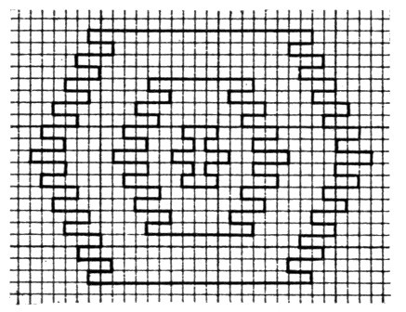 A Kiz-Kilim rug pattern

Patterns for Turkish rugs
In drawing designs for Turkish rugs, where the pattern is to be placed under the warp, it is better to make a squared paper first. Lay the head piece of the loom upon unlined paper. Place a dot at every other notch. Draw perpendicular lines first, then dot for horizontal lines. The result will be a foundation to fit your loom. If the squared[Pg 48] paper of the kindergarten be used the squares will be either too large or too small to correspond with the notches in the loom. It will be found very easy to transfer a pattern from a rug to the paper. Fasten the pattern under the warp by overhanding to the rods, taking care to have the black strings directly over the perpendicular lines in the pattern.

Patterns for Navajo blankets
Patterns for Navajo blankets are usually triangular. Draw on unlined paper and fasten under the warp as before.

To string a continuous warp for long strips
Rugs and similar articles may be made of any length by stringing a continuous warp. After the length has been decided upon, cut the warp strings twice as long. Place the middle of one string around the first tooth of the foot piece (or two or three, according to the width of warp desired) and bring up the two ends firmly to the first tooth in the head piece. Knot securely and let the long ends extend beyond the head piece. If desired they can be wound on spools, or around the tops of the rods, to prevent tangling. Continue until all the warp is strung. Observe the instructions given before for stringing warp strings in pairs. It is not necessary to weave the loom full each time, as the last inch is very slow work, but when the weaving[Pg 49] is near the head piece draw out the rods, lift it from the notches, pass it down to the foot piece so that the part which was at the head is now at the foot, untie the knots so that the work will lie close to the foot piece and knot the warp strings as before at the head piece. This can be done as many times as desired.

Methods of fastening long strips together
For afghans, slumber robes, couch covers, etc., crochet with plain stitch or baste on oil-cloth and weave together with tape needle, making it as nearly like the original weaving as possible. By studying Turkish rugs and curtains one can learn how to put strips together with a fancy stitch somewhat like our feather stitch.
Strips for floor rugs should be basted on oil-cloth and the warp strings in the two edges caught together at intervals, running the connecting thread through the loops so as to be invisible. Finish the outside edges by stitching on a tape of the same color, by machine.

Table covers, afghans, slumber robes, or large rugs
By making several of these long strips and fastening them together one can have a table cover, afghan, slumber robe, or a large rug.

Floor rugs
The floor rug shown in the illustration on page 100 (1-1/4 yards by 3/4 yard) is woven in[Pg 50] strips with a continuous warp. The center strip is one yard long and nine inches wide. It is made of deep cardinal carpet wool. The strips of black, nine inches wide at the sides and ends, terminate diagonally, as seen in the illustration. The black diagonal lines show where the weaving ends. The warp is then tied and cut close to the weaving. The strips are to be sewn or crocheted together.

Fine weaving

To produce a design with the woof
For very fine weaving, where it is necessary for the warp threads to touch each other in order to produce a design with the woof, string a double warp in every notch with the same material. Then, with a tape needle, separate the warp threads, twist one over the other so that all will lie side by side, and secure them by weaving a few times across the loom. By using this method, one can have a close warp on the wooden looms.

Warp for doll towels
In stringing warp in pairs for doll towels, have two strings on each bar and one extending one notch beyond at each side. This makes a good fringe for the edges of the towel.

[Pg 51]

Chapter Five

MATERIALS

Silkoline
Plain and figured silkoline should be cut in bias strips one-half inch wide. Stretch and pull through the hands until both edges are raveled. When these strips are woven, the rug or mat will be reversible. Figured silkolines give a pretty mottled effect, especially those in which Turkish colors predominate. Rugs having plain centers and mottled borders are beautiful. A full-sized rug requires nearly two yards of material.

Cheese cloth
Strips of cheese cloth can be prepared in the same way. Cut them three-fourths inch wide on account of the tendency to ravel. Serviceable face and dish cloths can be made of white cheese cloth. Some of the colored cheese cloths make pretty rugs. When a desirable color cannot be found, the white cloth can be dyed at home.

Dress linings
Soft dress linings come in many beautiful colors. Old pieces may be utilized by cleaning and dyeing. The pieces are cut in bias strips, one-half inch in width.[Pg 52]

Silk
Pieces of old silk can also be prepared in this way. One can often obtain new pieces at dressmaking establishments.

Candle-wicking
Table mats, wash cloths, and similar articles can be made from candle-wicking. For lamp mats, cushion covers, and other articles the material may be dyed and woven in two colors, or in two tones of one color. A number of squares can be joined to make a hammock pillow. By stringing a close warp with white or colored wicking and weaving over and under one string with the same material, a coarse canvas can be made, upon which the children can cross-stitch a pretty border and center piece, or an all-over pattern by copying the kindergarten designs, or even initials and monograms. Most of the canvas sold at the stores, even the old Java canvas of our childhood days, is too fine for little children to work upon. In canvas made of candle-wicking by the child himself, the squares are large, and to this there is the added pleasure of the child being able to say when the work is finished, "I did it all myself."

Rope silk, or ropetine
Beautiful silk canvas can be made of rope silk and cross-stitched with another color or tone, or with chenille, making a velvet figure. This material is, of course, more[Pg 53] expensive. Two colors or two tones may be woven with chenille and silk in a kindergarten design. Beautiful holiday and birthday gifts can be made from these materials, such as mats, cushion covers, and sachet cases. Glove, mouchoir, necktie, fan, and trinket boxes can be made by weaving the top, bottom, and sides in panels. Foundation boxes, which may be purchased for a few cents, are excellent for this purpose, or they can be made very well at home from three-ply cardboard. Make the hinges of ribbon and line the boxes with silk of a corresponding or contrasting color.

Carpet ravelings
Carpet ravelings may be obtained from the carpet stores, or pieces of carpet can be raveled by the children. Let them have the pleasure and benefit which come from sorting the ravelings. It is an excellent lesson in color, besides developing the patience, concentration, discrimination, and judgment so much to be desired in other work. After the wool is sorted—not before, because it is not all fast color—dip in water, wring, and let the children straighten it gently, one piece at a time. This will make it as smooth and soft as new wool. Procure some small boxes—shoe boxes are a good size—place one color in a box with a sample fastened[Pg 54] outside at one end, and pile them upon a low shelf or window sill. Train the children to go to the "play store" to match their own wool. If they go quietly, one at a time, no one is disturbed and each child gains in knowledge of color as well as in independence. A little management of this kind helps the teacher as well as the child.

Carpet wools
New wools of various kinds and beautiful colors can be bought in large quantities from dealers in materials for industrial work. In some carpet departments you will find oriental wools which are used to mend rugs, and a small quantity can be bought. Some of the kindergarten supply stores and decoration companies have already advertised a stock of these materials.

Double Germantown wool

Germantown knitting yarn
An ideal material for little folks is double Germantown wool. The soft wool, used for both warp and woof, is excellent for weaving kindergarten designs. This should be done with a close warp, which may be extended each side of the head and foot piece as a fringe. By extending the warp any length desired beyond the head piece, long strips for slumber robes, afghans, and such articles can be woven. The warp may be strung with twine as near the color of the wool as possible, and a plain rug be made, with[Pg 55] colored stripes at each end. A very pretty and easy gift for a little child to make is a holder for the teapot, as described on page 92. The Germantown knitting yarn, which is more tightly twisted, makes very pretty rugs and mats. It is sometimes used for Navajo blankets.

Darning cotton
White dolls'-towels, with red or blue stripes, are made of darning cotton. Baste a small piece of canvas at one end and cross-stitch Miss Dolly's initial.

Knitting cotton
Plain white bedspreads, or white combined with a color in a kindergarten design, can be made of knitting cotton which is a little coarser than darning cotton. Knot a fringe on all sides. Lunch cloths and table covers for Miss Dolly can be made in the same way.

Macremé cord
Macremé cord is the best material for hammocks. It comes in many beautiful colors, at a few cents a ball.

Leather strips
To weave a kindergarten design in two colors of leather strips, have the leather cut the desired width, and fasten them to a piece of strong muslin at the top and bottom of the mat or panel. Fit the muslin over the teeth in head and foot pieces by cutting a small opening.

Celluloid strips

Leather strips
Celluloid strips may be treated in the[Pg 56] same way. Leather and celluloid strips can be woven free-hand like the paper strips.

Raffia
Many beautiful articles can be made of raffia, which is a palm fibre brought from the island of Madagascar. It can be obtained in the natural color at most of the department stores, the kindergarten supply houses, and the florists. The cost is usually 20 cents or 25 cents per pound, although the florists will sell a few cents' worth. It can be dyed easily, and with little expense, with Diamond or aniline dyes. It should first be washed. Care should be taken, in the selection, to obtain long, smooth pieces which will be at least one-half inch wide when wet, and of an even color. Some of the raffia is musty and badly spotted. It is well to wet all of it first, then straighten and allow it to dry. While weaving, keep the raffia moist by dipping the fingers now and then in a cup of water. Experience has proved this method to be more satisfactory than to allow the raffia to remain in water and become thoroughly soaked, particularly the colored raffia. If one cares to expend money instead of time and trouble, the raffia can be dyed in very beautiful colors at the dye houses.

Shetland wool
Blankets for Miss Dolly can be made of the soft Shetland wool and Germantown[Pg 57] zephyr. For bed blankets, cream color, with stripes of two or more colors, are very attractive. Carriage blankets made with white centers and colored borders, or with a tone for the center and a shade for the border, are a great addition to the carriage, as well as a source of comfort to the little occupant. Bind the edges with ribbon and run a narrow one through the beading formed by taking out the extra rods. This ribbon can be run all around the center part by leaving out a few woof threads at the top and bottom.

Knitting silk
By stringing a close warp of knitting silk and extending it the required length, shawl-straps, suspenders, belts, and garters can be woven. The rods should be adjusted for the desired width. Finish at each end with pieces of silk elastic of the same color, and with buckles.

Angora wool
Angora wool makes pretty Tam O'Shanters. Initials can be woven in any article.

Books of patterns
Small books containing cross-stitch designs can be found at the German and French embroidery stores in large cities—sometimes, but rarely, at the art counter in department stores. The "Kindergarten Guides" can be obtained at most public libraries, or a kindergartner friend will be glad to loan one.

[Pg 58]

Chapter Six

DIRECTIONS FOR DYEING

Diamond dyes
A few hints with regard to dyeing raffia, cheese cloth, white cord for hammocks, and other materials, may be found useful. For raffia use the Diamond dyes which are intended for wool or silk. Wash the raffia first. The color will be improved by soaking the raffia a day in alum water, one-half pound to the gallon. Dye once used can be kept in an air-tight dish and reheated whenever needed.

Vegetable dyes
Should one be interested in vegetable dyes much information can be obtained at the public libraries. Dr. Washington Matthews speaks of Indian dyes in his article on the Navajo weavers mentioned in this book. "How to Make and How to Mend" also contains some good suggestions about dyes.

Mrs. Candace Wheeler's pamphlet
In her little pamphlet, Home Industries and Domestic Weavings, published by the Associated Artists, 115 East 23d Street, New York City, Mrs. Candace Wheeler has an interesting chapter on "Rag-Carpet Weaving." Her suggestions for dyeing rags apply[Pg 59] equally to yarns and to other materials which may be used on hand looms for children. Through her kind permission I am allowed to quote the following suggestions:

Uses of the indigo tub
"In the early days of this present century a dye tub was as much a necessity in every house as a spinning-wheel, and the reëstablishment of it in houses where weaving is practiced is almost a necessity; in fact, it would be of far greater use at present than in the days when it was only used to dye the wool needed for family knitting and weaving. All shades of blue, from sky-blue to blue-black, can be dyed in the indigo tub; and it has the merit of being a cheap as well as an almost perfectly fast dye. It could be used for dyeing warps as well as fillings, and I have before spoken of the difficulty, indeed almost impossibility, of procuring indigo-dyed carpet yarn.

Blue universally used

Green
"Blue is, perhaps, more universally useful than any other color in rag-rug making, since it is safe for both cotton and wool, and covers a range from the white rug with blue warp, the blue rug with white warp, through all varieties of shade to the dark blue, or clouded blue and green rug, also, upon white warp. It can also be used in connection with yellow or orange, or with copperas or walnut dye,[Pg 60] in different shades of green; and, in short, unless one has exceptional advantages in buying rags from woolen mills, I can hardly imagine a profitable industry of rag-weaving established in any farmhouse without the existence of an indigo dyeing tub.

Red

Copperas

Dull green
"The next important color is red. Fortunately, red warps can be bought which are reasonably fast, but the only way to procure red rags in quantity is to dye them, and, although the dye is somewhat expensive, there are two colors, turkey red and cardinal red, which are extremely good for the purpose. Probably these could be bought at wholesale from dealers in chemicals and dyestuffs at much cheaper rates than by the small paper from the druggist or the country store. Copperas gives a fast nankeen-colored dye, and this is very useful in making a dull green by an after dip in the indigo tub.

Domestic dyes

Nut stains

Leaf stains

Iron rust

Ink stains
"There are some valuable domestic dyes which are within the reach of every country dweller, the cheapest and best of which is walnut or butternut stain. This is made by steeping the bark of the tree or the shell of the nut until the water is dark with color, and setting it with alum. It will give various shades of yellow, brown, dark brown,[Pg 61] and green brown, according to the strength of the decoction or the state of the bark or nut when used. If the bark of the nut is used when green, the result will be a yellow brown; and this stain is also valuable in making a green tint when an after dip of blue is added. Leaves and tree-bark will give a brown with a very green tint, and these different shades used in different rags woven together give a very agreeably clouded effect. Walnut stain will itself set or fasten some others; for instance, pokeberry stain, which is a lovely crimson, can be made reasonably fast by setting it with walnut juice. Iron rust is the most indelible of all stains, besides being a most agreeable yellow, and it is not hard to obtain, as bits of old iron left standing in water will soon manufacture it. It would be a good use for old tin saucepans, and various other house utensils which have come to a state of mischievousness instead of usefulness. Ink gives various shades of gray according to its strength, but it would be cheaper to purchase it in the form of logwood than as ink.

Vegetable dyes
"There is a strong and well-founded preference among art producers in favor of vegetable dyes, and yet it is possible to use[Pg 62] certain of the aniline colors, especially in combination, in safe and satisfactory ways.

The variety of shades
"Everyone who undertakes domestic weaving must know how to dye one or two good colors. Black, of course, and the half-black, or gray, which a good colorist of my acquaintance calls a light black. Indigo blue equally, of course, in three shades of very dark and light. Here are seven shades from the three dyes, and when we add white we see that the weaver is already very well equipped with a variety of color. The eight shades can be still further enlarged by clouding and mixing. The mixing can be done in two ways, either by carding two tints together before spinning, or by twisting them together when spun.

Carding and twisting
"Carding together gives a very much better effect in wool, while twisting together is preferable in cotton.

Blue

Pink

Gray

Clouding
"Dark blue and white and medium blue and white wool carded together will give two blue grays which cannot be obtained by dyeing, and are most valuable. White and red carded together give a lovely pink, and any shade of gray can be made by carding different proportions of black and white or half-black and white. A valuable gray is made by carding black and white wool[Pg 63] together, and by black wool I mean the natural black or brownish wool of black sheep. Mixing of deeply dyed and white wool together in carding is, artistically considered, a very valuable process, as it gives a softness of color which it is impossible to get in any other way. Clouding, which is almost an indispensable process for rug centers, can be done by winding certain portions of the skeins or hanks of yarn very tightly and closely with twine before they are thrown into the dye pot. The winding must be close enough to prevent the dye penetrating to the yarn. This means, of course, when the clouding is to be of white and another color. If it is to be two shades of one color, as a light and medium blue, the skein is first dyed a light blue, and after drying, is wound as I have described, and thrown again into the dye pot, until the unwound portions become the darker blue which we call medium."

Mrs. Albee's manual
Through the courtesy of Mrs. Helen R. Albee, who has done much to revive an interest in rug-weaving, I am allowed to quote the following detailed suggestions on the subject of dyeing from her helpful manual, Abnákee Rugs. This little manual treats fully of the "Abnákee Rug Industry," the[Pg 64] "Materials," "Methods of Work," and "Dye Formulas." It was issued through the Riverside Press in 1901.
Speaking of combinations of color, Mrs. Albee says:

Combinations of color

Safe tones

Colors in rugs

Use of white
"A careful study of the effects of colors upon each other will show that colors which are in themselves beautiful are often inharmonious when combined. Also, a little of a color may be good, when a larger proportion seems to destroy the balance or harmony. Success in this matter is largely a matter of close observation and experience, although some persons have a natural feeling or instinct regarding color which is seldom in error. Strong colors should never be used, especially greens. Though they may be modest in the piece, when worked in with other colors, they have an unfortunate way of becoming intensified tenfold. The safest tones for an amateur to deal with are dull gray green, yellow green, and a soft, full, but dark olive. In striking a certain key in color it should be maintained throughout. Thus, if a full rich color predominates, rich dark colors should be used through the whole scheme. If a light tone is the body color, soft light tones of other colors will be found most harmonious.[Pg 65] Thus, for example, a rug for a library, or a hall, in which a good deal of rich terra cotta appears, should have a border or design worked in dark blues, full shades of olive green, and dull yellow. There is an apparent exception to this in the use of dull reds, old ivory, and black as seen in Bokhara rugs. But if studied, the cream color is very dull, and is used in such small quantities as to be quite subdued by the black that is used freely in the pattern. Old rose, warm golden browns, and olive may be used effectively. A light Gobelin blue may be worked with ivory, old pink, light dull olive, and the outlines can be either a dark yellow brown or very dark bronze green. An ivory center is lovely with an old pink border worked in green. A tan center may be combined with old rose, sage green, bronze green, light yellow, cream color, and dark brown outlines. Indigo blue, forest green, and dull yellow are excellent colors when combined. A great variety of beautiful rugs may be made by using only blue and white, and unless one wishes to go extensively into dyeing, it might be well to choose a certain simple color scheme such as blue and white, red, black, and ivory, and abide by it. Let it be remembered that white in rugs is not[Pg 66] white, neither is it a delicate cream. Unless it is decidedly yellowish or even grayish in tone, when in combination with other colors, it becomes a staring white that is anything but artistic. I dye my cream colors, just as much as I do dark reds or greens.

Planning a color scheme for a rug
"I have been asked many times what is the best way to plan a color scheme for a rug. This is a point I cannot determine for another. Some may find help in making water color sketches of what they wish to do. In my own work I never use them, as it requires making a reduced drawing of great accuracy, and much time to color it. Often I plan a combination mentally, and match it up from the dyed flannels I always have on hand. Other times I vary the scheme of some rug I have already made, experimenting with different combinations, using other rugs as if they were books of reference. I have discovered one rather curious thing, which is, that when all my experimenting is done I find some particular color scheme fits a certain rug as no other does. It seems to clothe or to fulfill the pattern as if it belonged personally to it. When I once discover this elective affinity of a pattern for its special coloring, I never make it again save in that one guise.[Pg 67]

Shading

Directions for shading
"Much skill can be shown by an artistic worker in the use of slight shades of difference in the same color. For example, in the plain center of a rug, several tones representing shades of the same color will give the effect of a play of light on a silky surface, which is very beautiful. By using material that has been dyed a trifle darker at one end of the rug, and working in gradually lighter tones, the result is surprisingly effective. To do this, each three or four yards should be dyed with these slight differences of tone; then when within thirty strips of the end of one color (more or less, according to the width of the rug), work in a broken line of the next tone all across the rug. Then use a few rows (not worked in single rows, however) of the first color across the entire rug, then a wider broken line of the second color. Broken lines blend better than continuous lines do. The portions of the second line should fall above the broken spaces left in the first line (in the same way that masons lay bricks), then a little more of the first color, using less and less of it, and increasing the width of the second in masses, until the first color has become only broken lines upon the ground of the second color. All the way through, any changes of[Pg 68] color should be merged in this way. Be sure to work this method from side to side across the rug, as the frameful is filled.

Coloring
"This is the most difficult feature of the whole handicraft, the actual coloring, and yet for fine effects I should recommend only the use of hand-dyed materials. Goods dyed by professional dyers are perfectly uniform in color throughout, and rugs made of such material will have nothing of that difference of tone, that play of color, that is absolutely necessary for beauty.

Dye kettles
"In dyeing use only brass, copper, granite, or porcelain kettles, unless one goes into it on a large scale and uses regular machinery. Brass and copper vessels are to be preferred, while iron, or tin showing iron, are to be carefully avoided, as the mordants have a great affinity for iron and ruin the color. I use a large brass kettle holding about five gallons.

Mordants
"For mordants I use Glauber salts and sulphuric acid, and with the weight of cloth I use, it takes 3 oz. of Glauber salts and 3/4 oz. of sulphuric acid (full strength) to each six yards of flannel. I use a one-ounce Phenix graduate (American standard) measuring glass, and as full strength sulphuric acid has about twice the specific gravity of water,[Pg 69] one should measure by the scale engraved on the right-hand side of the glass. The left-hand scale is based upon the standard unit of weight, which is water.

Uses of acids
"In using sulphuric acid I dilute it in a little cold water in a cup by pouring the acid on to the water, as sulphuric acid in uniting with water causes a chemical reaction. Where a large quantity of acid is used this reaction is accompanied by a sudden burst of steam, if the water falls upon the acid. But in a small quantity as this, there is no possible danger of accident if the acid is poured on the water. Sulphuric acid should be closely stoppered and used with care, as it is corrosive, eating holes in cotton or linen fabrics. With ordinary precautions it can be used without the least difficulty.

Salts set the dyes
"Glauber salts are too well known in commerce to need description, and are used to neutralize the acid. The two in combination do not injure woolen fabrics, but merely set the dyes.

Preparation of a dye bath
"In preparing the dye bath allow three gallons of water, and 3/4 oz. of sulphuric acid; stir thoroughly and add 3 oz. Glauber salts to six yards of cloth. Then add the dyestuff in required proportions. Stir thoroughly as each ingredient is added, for the evenness[Pg 70] of the dye depends upon the thorough distribution of the mordants and color in the dye bath. Generally it is advised to strain the dye before it is added, but, as an even tone is not the desired result for this special handicraft, I never follow this suggestion.

Coloring depends on temperature
"The proper temperature for introducing the color in the bath is not over 150° F., but if one has not a bath thermometer, the temperature must be very hot, yet far below boiling point. Temperature plays a great part in dyeing, for if the dye bath is too hot when the cloth is introduced, the dye, having a great avidity for wool, will be absorbed unequally by the cloth, the ends and outside folds of the cloth absorbing more color than is desired, and the inner folds will have less. I am not discussing the process of dyeing as it should be done on a large scale with vats and suitable reels, etc., but as it is likely to be done by an amateur, in a small way. When the bath is too hot, the cloth takes the dye unequally and is quite spotted. A little irregularity is necessary for a play of color, but it should be secured in a definite way and only to a certain degree, and not as the result of accident. If the cloth has come out spotty, it may be redipped, having added more dye and mordants to the bath,[Pg 71] but it will come out a darker shade. If the bath is anywhere near the boiling point before the cloth is dipped, reduce it by adding a quart or two of cold water."

Process of dyeing yarn or raffia

Clear days are best for dyeing
Before dyeing yarn or raffia, bind the skeins loosely in several places to prevent tangling. "Having prepared the bath, gather the cloth in the right hand at half a dozen places along one selvedge, and drop it in, spreading it at once, using two stout sticks, lifting it up and down continually so as to expose all parts to the dye. The temperature should be increased to the boiling point and continued for three-quarters of an hour. Then lift the cloth up and drain it, then rinse in cold water, wring dry, but do not press with an iron, as the soft wooly texture is very desirable. When a quantity of the same color is desired, the same water can be used again by adding acid and Glauber salts, together with more dyestuff with each fresh dip of cloth. It must be stated, however, that the color will not be so clear with succeeding dips, but that does not matter, as a difference is desired. The process of dyeing is very delicate, and the utmost precision must be observed in following proportions and directions regarding temperature, etc. Dyeing is more successful in clear weather[Pg 72] than on rainy days, and soft water is required to get good results. If water contains much lime or earthy salts it is unfit for dyeing, and must be neutralized by acetic acid. In such cases it would be still better to use rain water.

Vegetable dyes and chemical dyes compared
"There is a curious conviction prevailing in some quarters that beautiful durable colors are obtainable only from vegetable dyes. My first experiments were with barks, mosses, etc., but the difficulty of getting them, the enormous amount necessary to dye any quantity of goods, the tedious process in their use, and the fact that after all only a narrow range of colors is obtainable from them, compelled me to abandon them altogether. I began to investigate chemical dyes, and to gain information I applied to one of the largest woolen mills in New England, one which maintains a high reputation for the class of goods it manufactures; also to two wholesale houses dealing in all kinds of dyestuffs; and finally to one of the best experts in color in the country. Their verdict was unanimous, and is summed up in the opinion of the expert which he expressed in a letter to me on this question:
"'In regard to the use of vegetable dyes, I would say that they have almost disappeared[Pg 73] from commerce, certainly for the purpose of dyeing fabrics.

Aniline colors
"'We know, of course, that there are strong prejudices still existing in the layman's mind in regard to the use of aniline colors, who supposes that they are not only fugitive, but that the resulting tones are harsh and unattractive. This, unfortunately, was so twenty-five years ago, and the impression made then upon the layman's mind has not been changed during all these years; but I can assure you that all the beautiful silk goods, tapestries, cloths, and all the colors which we see in fabrics to-day, are made, without exception, from aniline colors, which are immeasurably more permanent than are the vegetable dyes used up to, say, 1875.'

Formulas to be followed
"In using my range of eight colors I provide myself with large, strong glass bottles in which I keep my diluted colors. I use a pint measure for diluting the dyes. In preparing the fluid I put one half or one quarter of an ounce of dry color, whichever amount the formula calls for, into the pint measure and mix it thoroughly with a little cold water. The reason for using cold water is that the dyes are a tar product, and if mixed with hot water first, they are apt to[Pg 74] grow waxy under the heat and not dissolve readily. Having dissolved them, I fill up the measure with hot water, stirring all the time. This makes a pint of liquid which is of uniform strength under all circumstances, and every formula is based upon this invariable pint measure of water. These formulas I have tried over and over again. They are made with special reference to the grade of flannel I have adopted, and doubtless will vary in results if used on other weights or weaves of wool goods."

DYE FORMULAS

NO. 1. DARK TERRA COTTA

Dark terra cotta
Dissolve 1/2 oz. of dull red in 1 pint of water.
Dissolve 1/4 oz. of green in 1 pint of water.
Take full pint measure of dull red dye and 4 tablespoonfuls of green dye to 6 yds. of cloth.
Mordants: 3/4 oz. sulphuric acid and 3 oz. Glauber salts. Boil 3/4 of an hour.

NO. 2. FULL TERRA COTTA

Full terra cotta
Dissolve 1/2 oz. of dull red in 1 pint of water.
Use full pint measure of dull red dye to 6 yds. of cloth.[Pg 75]
Mordants: 3/4 oz. sulphuric acid and 3 oz. Glauber salts.

NO. 3. LIGHTER TERRA COTTA

Lighter terra cotta
Dissolve 1/2 oz. of dull red in 1 pint of water.
Use 22 tablespoonfuls of dull red dye to 6 yds. of cloth.
Mordants: 3/4 oz. sulphuric acid and 3 oz. Glauber salts.

NO. 4. RICH OLD RED

Rich old red
Dissolve 1/2 oz. of dull red in 1 pint of water.
Dissolve 1/4 oz. of green in 1 pint of water.
Use 24 tablespoonfuls of dull red dye and 3 tablespoonfuls of green dye to 6 yds. of cloth.
Mordants: Same as No. 1.

NO. 5. DULL OLD ROSE

Dull old rose
Dissolve 1/4 oz. of dull red in 1 pint of water.
Dissolve 1/4 oz. of bright blue in 1 pint of water.
Dissolve 1/4 oz. of dull yellow in 1 pint of water.
Use 16 tablespoonfuls of dull red dye, and 1 tablespoonful of bright blue dye, and 3[Pg 76] tablespoonfuls of dull yellow dye to 6 yds. of cloth.
Mordants: Same as in No. 1.

NO. 6. OLD PINK

Old pink
Dissolve 1/4 oz. of dull red in 1 pint of water.
Dissolve 1/4 oz. of dull yellow in 1 pint of water.
Dissolve 1 oz. of dark blue in 1 pint of water.
Use 6 tablespoonfuls of dull red dye, and 3 tablespoonfuls of dull yellow dye, and 1-1/2 teaspoonfuls of dark blue dye to 6 yds. of cloth.
Mordants: Same as in No. 1.

NO. 7. FULL YELLOW

Full yellow
Dissolve 1/4 oz. of bright yellow in 1 pint of water.
Dissolve 1/4 oz. of dull yellow in 1 pint of water.
Dissolve 1/4 oz. of green in 1 pint of water.
Use 6 tablespoonfuls of bright yellow dye, and 5 tablespoonfuls of dull yellow dye, and 2 tablespoonfuls of green dye to 6 yds. of cloth.
Mordants: Same as in No. 1.[Pg 77]

NO. 8. RICH DULL YELLOW

Rich dull yellow
Dissolve 1/4 oz. of bright yellow in 1 pint of water.
Dissolve 1/4 oz. of dull red in 1 pint of water.
Use 12 tablespoonfuls of yellow dye and 6 tablespoonfuls of dull red dye to 6 yds. of cloth.
Mordants: Same as in No. 1.

NO. 9. DARK TAN YELLOW

Dark tan yellow
Dissolve 1/4 oz. of dull yellow in 1 pint of water.
Use 14 tablespoonfuls of dull yellow dye to 6 yds. of cloth.
Mordants: Same as in No. 1.

NO. 10. LIGHT OLIVE TAN

Light olive tan
Dissolve 1/4 oz. of bright yellow in 1 pint of water.
Dissolve 1/4 oz. of dull yellow in 1 pint of water.
Dissolve 1 oz. of dark blue in 1 pint of water.
Use 6 tablespoonfuls of bright yellow dye, 4 tablespoonfuls of dull yellow dye, 1-1/2 tablespoonfuls of dark blue dye to 6 yds. of cloth.
Mordants: Same as in No. 1.[Pg 78]

NO. 11. OLD IVORY

Old ivory
Dissolve 1/4 oz. of bright yellow in 1 pint of water.
Dissolve 1/4 oz. of drab in 1 pint of water.
Dissolve 1/4 oz. of dull red in 1 pint of water.
Use 1 teaspoonful of yellow dye, and 1 teaspoonful of drab dye, and 1/4 teaspoonful of dull red dye to 6 yds. of cloth.
Mordants: Same as in No. 1.

NO. 12 RICH NAVY BLUE

Rich navy blue
Dissolve 1 oz. of dark blue in 1 pint of water.
Use full pint measure of dark blue dye to 6 yds. of goods.
Mordants: 1 oz. sulphuric acid, 3 oz. Glauber salts. Boil 1 hour.

NO. 13. DARK PERSIAN BLUE

Dark Persian blue
Dissolve 1 oz. of dark blue in 1 pint of water.
Dissolve 1/4 oz. of green in 1 pint of water.
Use 10 tablespoonfuls of dark blue dye, 6 tablespoonfuls of green dye to 6 yds. of cloth.
Mordants: Same as in No. 12.

NO. 14. GOBELIN BLUE

Gobelin blue
Dissolve 1 oz. of dark blue in 1 pint of water.[Pg 79]
Dissolve 1/4 oz. of green in 1 pint of water.
Use 6 tablespoonfuls of dark blue dye, 4 tablespoonfuls of green dye to 6 yds. of cloth.
Mordants: Same as in No. 12.

NO. 15. LIGHT GRAY BLUE

Light gray blue
Dissolve 1 oz. of dark blue in 1 pint of water.
Dissolve 1/4 oz. of green in 1 pint of water.
Use 3 tablespoonfuls of dark blue dye, 2 tablespoonfuls of green dye to 6 yds. of cloth.
Mordants: Same as in No. 12.

NO. 16. LIGHT SAGE GREEN

Light sage green
Dissolve 1/4 oz. of green in 1 pint of water.
Dissolve 1/4 oz. of bright yellow in 1 pint of water.
Dissolve 1/4 oz. of dull red in 1 pint of water.
Use 10 tablespoonfuls of green dye, 2 tablespoonfuls of bright yellow dye, and 1-1/2 tablespoonfuls of dull red dye to 6 yds. of cloth.
Mordants: Same as in No. 1.

NO. 17. LIGHT OLIVE

Light olive
Dissolve 1/4 oz. of green in 1 pint of water.
Dissolve 1/4 oz. of bright yellow in 1 pint of water.[Pg 80]
Dissolve 1/4 oz. of dull red in 1 pint of water.
Use 16 tablespoonfuls of green dye, 4 tablespoonfuls of bright yellow dye, and 3 tablespoonfuls of dull red to 6 yds. of cloth.
Mordants: Same as in No. 1.

NO. 18. DARK MOSS GREEN

Dark moss green
Dissolve 2 level teaspoonfuls of green in 1 pint measure of water.
Dissolve 1/4 oz. of bright yellow in 1 pint of water.
Use full pint measure of green dye and 15 tablespoonfuls of bright yellow dye to 6 yds. of cloth.
Mordants: 3 oz. of Glauber salts and 1 oz. of sulphuric acid. Boil 3/4 of an hour.

NO. 19. GOLDEN BROWN

Golden brown
Dissolve 1/4 oz. of dull yellow in 1 pint of water.
Dissolve 1/4 oz. of dull red in 1 pint of water.
Dissolve 1/4 oz. of green in 1 pint of water.
Use 20 tablespoonfuls of dull yellow dye, 5 tablespoonfuls of dull red dye, 15 tablespoonfuls of green dye to 6 yds. of cloth.
Mordants: Same as in No. 18.[Pg 81]

NO. 20. DARK BRONZE

Dark bronze
Dissolve 1/4 oz. of green in 1 pint of water.
Dissolve 1/4 oz. of dull red in 1 pint of water.
Dissolve 1 oz. of dark blue in 1 pint of water.
Dissolve 1/4 oz. of bright yellow in 1 pint of water.
Use 8 tablespoonfuls of green dye, 12 tablespoonfuls of dull red dye, 4 tablespoonfuls of dark blue dye to 6 yds. of cloth.
Mordants: Same as in No. 18.
Redip in 4 tablespoonfuls of green dye and 5 tablespoonfuls of bright yellow dye.
Mordants: Repeat the one above.

These formulas are the basis for numerous tones
"These formulas can be taken as the basis of many other tones and shades which can be secured by a slight alteration of proportions. By adding a trifle more dull red, green, indigo, or drab liquid dyes, a color can be darkened. By using less of these than the formulas call for, the colors will be lighter. By using more of dull or bright yellow a color can often be made richer without darkening it. Beginners are cautioned against making changes until they become familiar with the dyes. In making new experiments, try them on yard lengths,[Pg 82] carefully subdividing any given formula for both dyes and mordants, and increasing the proportion of any particular color desired. If the cloth should fail to take up the dye properly after boiling the full time, increase the quantity of acid, lifting the cloth out when adding the acid to the dye bath."
Excellent suggestions by Miss Albee for color schemes in stripes may be found on pages 64 and 65.
[Mrs. Albee is prepared to furnish any of the foregoing dyes at 20 cents an ounce. Her address is Mrs. Helen R. Albee, Pequaket, Silver Lake P. O., N. H.]
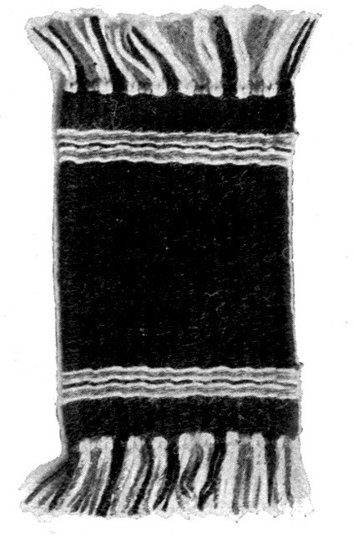 A deep blue wool rug made of carpet yarn

[Pg 83]

Chapter Seven

METHODS OF SPLICING MATERIALS FOR WEAVING

Woolens, fine worsteds, ravelings, and cottons
Such materials as carpet and oriental wools, fine worsteds, carpet ravelings, darning and knitting cotton should, in splicing, be run past each other. In weaving, run the wool through the warp to the very end. Start the new piece a few warp threads back, being careful to go over and under exactly the same warp threads as you did when finishing the end. As you pass these threads you will find that you are taking up the right warp threads, and that no mistake has been made. It is best to run the threads past each other in the middle of the mat rather than on the sides. The children learn this method of splicing very quickly and the result is much more satisfactory than knotting, because the back of the rug or mat will be smooth. As Mrs. Wiggin says: "There should never be a wrong side to work any more than there should be to folks."

Silkoline, cheese cloth, rags

Candle-wicking, chenille, and macremé cord
In splicing such materials as silkoline, rags, candle-wicking, chenille, and macremé[Pg 84] cord, lay the end of one piece over another, each lapping about one-quarter inch, and sew securely with silk or thread of like color. Cut off the selvedge ends of rags. These strips can be run past each other, but the work will not be so smooth.

Germantown wool, heavy worsteds, and rope silk
In splicing Germantown wool, heavy worsteds, or rope silk, thread a worsted needle with one strand obtained by unwinding the wool or silk, lay one end over the other, and sew over and over. Twist the part just sewn between the thumb and finger and the splicing will be hardly visible.
When weaving stripes, splice the wool so that the piecing will come on top of the rod. In this way the new color will start at the edge of the rug, as it should, and the number of loops on the rod will be the same on each side. Consider the under side of the weaving as the right side. It is always smoother and cleaner, and the splicing can be done more neatly on top of the rod.

Raffia
Splicing raffia is the most difficult of all, and the method used in braiding and basket weaving is the best. As you near the end of a strip in weaving it usually becomes narrower. Find another strip having a narrow end, and place one over the other, securing, if necessary, by winding a very narrow piece—just[Pg 85] a thread torn from a long piece—and fastening this by sewing a few times over and over. Or, the two narrow ends may be run past each other, as in carpet ravelings. Care should be taken to have the splicing the same width as the other parts of the weaving, so that the spliced parts will not be noticeable.

Leather, leatherette, and celluloid strips
Leather, leatherette, and celluloid strips should be long enough to extend the entire width and length of the frame without splicing. The ends can be cut, as is done in paper weaving, or turned in some pretty way like that in the splint work.

[Pg 86]

Chapter Eight

WOOL AND SILKOLINE RUGS OR MATS
Silkoline rug with three white stripes

Plain rug with end stripes

Finishing the ends
Silkoline rugs or mats are by far the prettiest for doll-house use. The method of preparing the strips is explained under Materials (page 51). Make the warp with twine of the same color as the silkoline. It should be a three-eighths-inch warp. Choose a plain color for the body of the rug, and a short distance from each end weave several stripes of a contrasting color. The rug in the illustration is of deep cardinal. The stripes can be of olive green, black, or any preferred color. Mottled stripes are also attractive and effective. When the stripes at the foot are woven, ascertain the distance from the foot piece to the last one. To know where to commence the first stripe at the head, measure the distance just found from the head piece down, and mark on both rods by tying[Pg 87] or sewing a colored string to the warp. This helps the child to understand where the stripe should begin, which he soon learns to measure for himself; and this training in accuracy and independence is most excellent. There is nothing better than learning self-reliance, and the child who has been taught it, is not apt to ask others to do his examples for him. To learn the manner of making the stripes and spaces each of the same width, count the loops on the rods (one has to weave twice across the loom to have one loop on a rod), and have the same number on each side. Care should be taken not to twist the strips in weaving. The method of splicing the strips and fastening the warp strings is explained in Chapter V. The rug may be finished with a wool or silk fringe of the predominating color, or a fringe of the combined colors. If desired, it may be left plain, catching the woof strips together at each end to conceal the warp strings. When a mistake has been made, run the needle back under the same strings instead of pulling out what is wrong. It prevents stretching and a destruction of the material.

Mottled rugs made of figured silkoline
Mottled rugs are made of figured silkoline. Choose oriental colors, no matter how gaudy the silkoline may look in the piece.[Pg 88] It will have a beautiful effect when woven. Portières are pretty made in this way. These rugs should always be plain—that is, without stripes.
A mottled rug of figured silkoline, in which the colors brown, blue, and old gold predominate
[Pg 89]
Plain rugs with mottled borders, or mottled rugs with plain borders
Plain rugs with mottled borders, or mottled rugs with plain borders, are the delight of the children. Adjust the frame for the size required, and decide how wide the border is to be. It is necessary to have an extra pair of rods, if one desires a smooth and well-finished rug. The border of the rug represented in the illustration is two inches. This should be woven with a tape needle. Weave the border at the foot of the loom. This extends the entire width. Place the extra rods two inches toward the center from the side rods on the outside of the rug, keeping them back of the border already woven at the foot. This will outline the sides of the plain oblong in the center. Weave the left and right hand borders up to a point two inches from the head piece, taking care to go around the rods just placed. Then begin the plain center. As you come to the border on each side, run your tape needle through the loops of mottled silkoline which are around the rod, but do not go around the rod itself with the plain silkoline, since doing so would make a ridge in the rug. Draw the woof strips tightly and firmly, so that the work will lie flat and smooth when removed from the loom. Be sure to weave the center far enough, remembering that the upper woof[Pg 90] strips in the border will crowd it down. When the center is finished, remove the extra rods and finish weaving the border to[Pg 91] the head piece. In selecting a color for the center, match one of the colors in the figured silkoline. The color for the center in the rug of the illustration on page 90 is green, and the same color appears also in the mottled border, with yellow and brown. The ends should be left plain, the warp strings being concealed as directed. These rugs are very beautiful, and can be made in an infinite variety through the use of different colors, and by reversing the center and border. They can be made of carpet or Germantown wool, in two colors or in two tones of one color. In weaving rugs with centers and borders, weave a little farther than the exact measure, because the next woof threads will push down the woof already made, and you may find that you have not woven the correct measure. These rugs are useful as "heel rugs"; they are placed under the piano near the pedal to protect the carpet from the pressure of the heel. (See also page 82.)
A plain silkoline rug, with a mottled border

Holder or mat

Many squares joined together

Small rug with fringe

Stair and hall carpets
Adjust the loom for the size required. The plaid effect in the holder illustrated on page 92 is obtained by stringing a close warp with green and white carpet wool, alternating two of white with four of green. In weaving, use two woof threads of white and four of green to make the square correct. The[Pg 92] kindergarten designs make pretty holders. If you have woven a holder, it will be finished when it is removed from the loom and the warp strings have been fastened. If you wish your holder to be very thick, weave two of these pieces, lay a square of felt or flannel between and sew or crochet the edges together. If the work is to be a mat, knot a pretty fringe all around it. Many of these squares can be joined to make sofa pillows, afghans, slumber robes, and other dainty articles. With a continuous warp, one can weave long strips for the same articles. If a small rug for Miss Dolly's bedroom is desired, string the warp so that the two ends will have a fringe. Stair and hall carpets for the doll house can be woven in these pretty designs by adjusting the loom for a narrow strip, and, if necessary, a continuous warp.
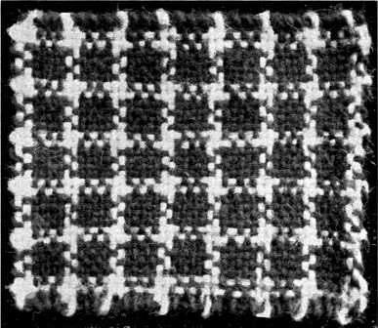 Holder of green and white carpet wool

[Pg 93]

Chapter Nine

HAMMOCKS
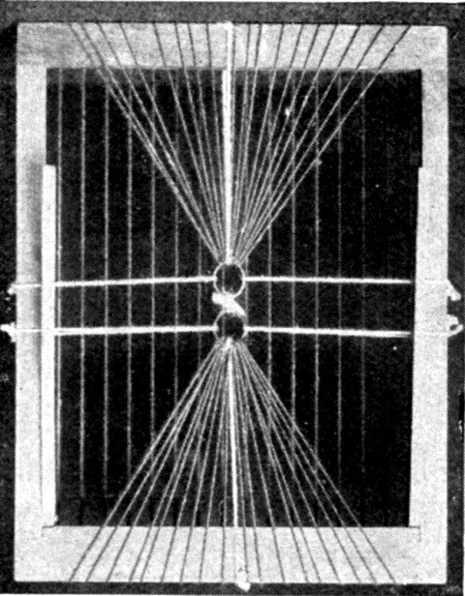 Back of loom, showing method of stringing warp through rings for a hammock

Method of adjustment

Use of stripes for various colors

Lengthwise stripes
To weave a hammock, one must first adjust the loom to its full size. Tie two rings together and fasten them at the back of the loom, to head, foot, and sides, as in the illustration. One must then decide how close the warp is to be strung. Measure the string, which should be continuous, allowing enough to go to the rings at the back and make a buttonhole stitch each time. Then wind on a long thin stick or dress steel, in such a way that it will pass easily through the rings. In stringing the hammock in the illustration, a penholder was used. The rings are tied, with white cord, to the four sides of the loom. By doing this, all tangling of the warp string is avoided, and it is far preferable to splicing. Tie the first warp string to the top ring. Draw it tightly through the first groove,[Pg 94] over the face of the loom to the opposite groove, then to the back of the loom through the bottom ring. Make a buttonhole stitch and return in the same manner over the face of the loom, around to the top ring, where you make a buttonhole stitch and return, until the whole warp is strung. Care should be taken to make it firm and tight. Hold the string and ring firmly in the left hand while making the buttonhole stitch with the right. Cut the woof cords long enough to allow a fringe on each side of the hammock. Weave each cord separately, tying in pairs around the rods. Stripes of one or more colors can be woven at each end or at intervals through the hammock. By weaving two colors alternately, the stripes will be lengthwise instead of crosswise. Knot the fringe at each side. To fasten the top and bottom woof cords so that they will not pull out of place, thread a tape needle with cord and tie each warp string close to the woof. Another way to secure the top and bottom woof cords is to weave two cords at one time, twisting one over the other between the warp strings. The bottom one should be woven before the hammock is commenced. The top one can be woven before the hammock is finished, and pushed[Pg 95] up close to the head piece. Then fill up the space.
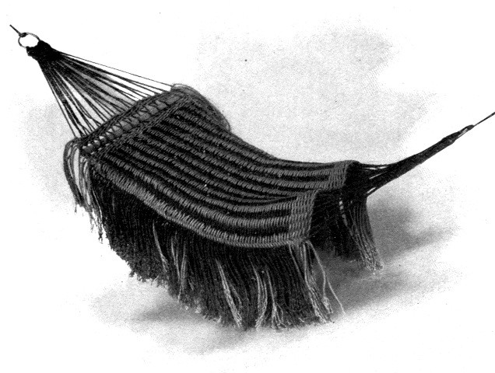 A hammock made from strings of different colors in lengthwise stripes

Making the fringe

The stretcher

The head-rest

Hammock with lengthwise colored stripes

Knotted hammocks
Instead of knotting the fringe as suggested, two cords can be twisted at each side of the hammock in the same way that the woof cords are secured at the top and bottom. This forms a heading for the fringe. Take up two cords of the fringe at a time. If desired, the strings which extend from the rings to the hammock may be woven for the space of an inch or so close to the rings[Pg 96] instead of making a buttonhole stitch. Make a stretcher for the head by covering a piece of rattan with buttonhole stitch. Fasten this to the hammock. A head-rest can also be woven and adjusted. To remove the hammock from the loom, cut the two rings apart, and then lift the warp strings from the grooves. A very pretty hammock can be made by stringing the warp of different colors, in order to make lengthwise stripes. Weave a neutral color through them. In this case, have a close warp. Pretty hammocks can be made by knotting instead of weaving.
To string warp for hammock in order to have the sides shorter than the center
Cut two semi-circular pieces from light wood or pasteboard. These should suit the width of the hammock to be made. If this is the width of the loom, then 9-1/2 inches long and two inches at the widest part. Cut the curved edge in notches to correspond with the number taken in the head piece. These pieces will be firmer and more satisfactory if made of wood and finished at the lower edges like the metal head piece. This can be easily done by glueing them to a narrow piece of wood so that they will stand. If furnished with perforations, they can be laced to the head and foot pieces or the rods can be run through them. By stringing the warp in this way, the sides of the hammock[Pg 97] will be shorter than the center, and there will be no danger of Miss Dolly falling out.
The warp can be strung more quickly and easily if hammock hooks similar to those in the two illustrations below are used. Measure the right length—22 warp strings 31 inches long for the metal loom, or 29 the same length for the wooden loom—and wind as before.
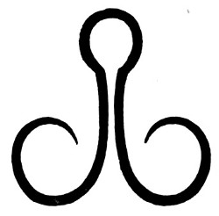 Hook No. 1
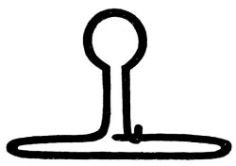 Hook No. 2

Hammock hooks

Weaving
In using hammock hook No. 1, knot half the number of warp strings in the left-hand ring and half in the right-hand ring. If hook No. 2 be used, unpin the part at the right, knot the warp strings along the straight edge at the bottom, and then pin the right-hand part again. Weaving each cord separately across the loom makes a heavy fringe at the sides. If a lighter fringe be desired, cut the woof cords twice the width of the loom plus twice the length of the fringe. Weave across the loom, leaving enough for the fringe at the side, then around the rod and back again, drawing the cord through to the same length as the part left at first.[Pg 98] Weave in the same way with the second color, having the loop on the same rod and the fringe at the same side as the other. Weave the next two cords with loops on the opposite rod and fringe on the opposite side. Continue in this way until the hammock is finished. Make a heading at the sides as described, only carry the two cords through the loops, crossing them between on top of the rods. The warp strings can be passed through the rings without buttonholing. A firm pretty finish can be made at the sides by cutting two cords—one of each color two yards long and buttonholing around the rods on top of the woof cords which extend at each side. Fasten these long cords at the bottom of the loom. After two pairs of woof cords have been tied, buttonhole the edge over them and around the rods and continue this until the hammock is finished.
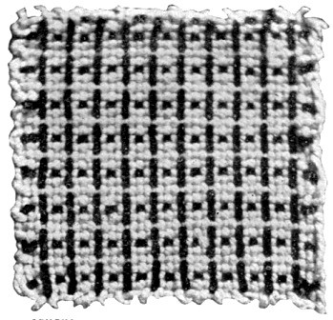 A square of silk canvas

[Pg 99]

Chapter Ten

FACE AND DISH CLOTHS AND BATH RUGS
A face cloth made from cheese cloth

Materials
The materials for making face and dish cloths are: cheese cloth cut bias, darning or knitting cotton, or candle-wicking. Those made from cheese cloth resemble the Turkish rags. Cut and splice the cheese cloth according to directions on page 83. The face cloth in the illustration is made from white cheese cloth, cut bias. String the warp 3/16 inch with white twine. It being desirable to have face and dish cloths as soft as possible, do not push the woof threads too closely together. When the cloth is removed from the loom, conceal the ends of the warp strings as previously[Pg 100] directed. Fine white thread should be used. If preferred, the edges can be bound with tape. Cloths of candle-wicking are very quickly woven, but they are not so soft.
Face cloths of cheese cloth with borders of knitting cotton would be durable and satisfactory. Make them according to directions given for rugs with centers and borders.
Cross-barred face cloths made of knitting cotton No. 4, in two colors, are very pretty.

Bath rug made with continuous warp
Serviceable bath rugs can be made by making three strips as long as desired, and then fastening together. They are made of cheese cloth cut bias, but the woof threads are packed much tighter than in the face cloths. Finish the edges by stitching a white tape all around. Floor rugs of any kind can be made firmer by finishing in this way with tape of the same color.
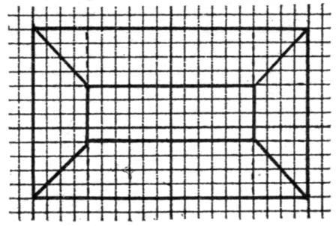 A pattern for a floor rug

[Pg 101]

Chapter Eleven

RAFFIA MATS
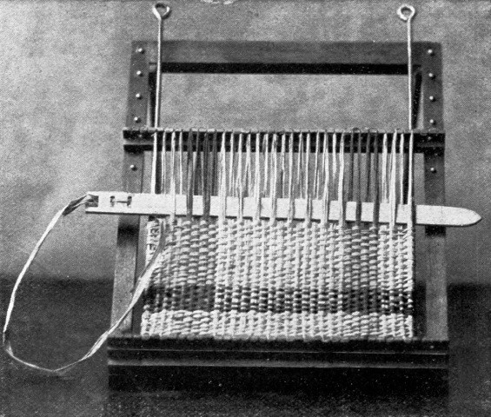 Method of weaving a raffia mat on the loom, showing colored stripes

Method of making raffia mats

The rods and the warp strings in kindergarten patterns
Mats of raffia are made like all the other mats. The warp may be of twine or carpet thread. In this case, the mat should be woven of raffia in the natural color, with stripes of bright color at each end; or, it may be of some dark tone with stripes of a[Pg 102] contrasting color. By using a warp of raffia, many of the beautiful kindergarten designs can be produced. Use one color for the warp and another for the woof. The method of stringing a warp of raffia is described in "Methods of Stringing Warp," on page 45. The illustration shows a raffia mat in process of making. The natural color of raffia is used, with stripes of cardinal, and the method of stringing color in the warp to obtain this effect is clearly seen. The children will have no difficulty in carrying out the pattern, if they remember that the rods correspond to the border of the paper mat. Before stringing the warp for a kindergarten pattern, count the strips in the paper mat and begin to count on the loom from the rods. In this kind of work the string on top of the rod does not count. It forms the border of the mat.[Pg 103]
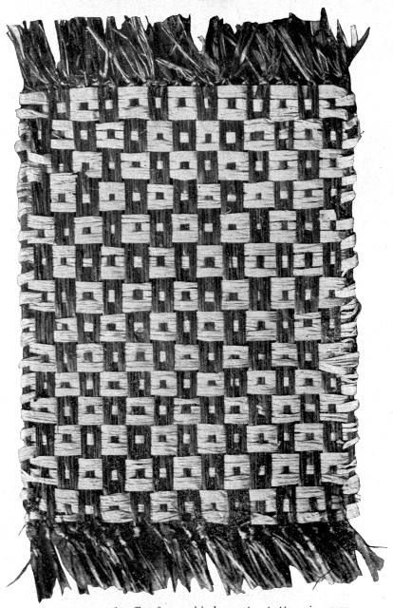 A woven mat of raffia, from a kindergarten pattern in green and the natural color of the raffia
[Pg 104]

Stringing the warp
In making mats, or matting, of raffia, the material can be carried over the rods as in wool-weaving, or it can be finished on the edges in the same way as the real matting is done. This will be easily understood by examining a piece of matting. In stringing the warp, have three strings over each bar instead of one. Cut the woof strips several inches longer than the width of the loom. Weave the first strip, leaving a piece at each side. Thread a tape needle with one end and weave it in and out the three warp threads on the rod. Then cut it off close to the edge. Finish off all the ends in this way. When the work is removed from the loom, press the edges flat with a warm iron. It is a little easier to keep the pattern right by weaving in this way, and the work resembles the real matting more nearly. Use a tape needle for weaving raffia.

Porch curtains
If the doll house which we are fitting is a large one with porches, one could complete the furnishings with a porch curtain, for sunny afternoons.

Glove, trinket, and mouchoir boxes
Boxes of all kinds can be made of raffia woven in panels. It will make the box stronger and firmer to overhand a piece of rattan around the edges of the panels before joining them in the form of a box. Thread a worsted needle with a narrow strip of raffia and buttonhole the edges of the panels together; or, sew them over and over and cover with a braid of raffia. Spiral-weaving is pretty for this finishing. It is described in an article entitled "Straw-Weaving," in "American Homes" for September, 1900, a magazine published in Knoxville, Tenn. Glove, trinket, and mouchoir boxes are pretty[Pg 105] for holiday gifts. By using different patterns and colors a great variety of them can be made.

Rugs of carpet wool
For rugs made of carpet wool, string a three-eighths-inch warp of twine, or oriental cord, the color of the body of the rug. Use a deep tone of red, olive green, or any preferred color, with a stripe at each end. A study of rugs will soon enable one to get the right proportion of rug and stripe. Beautiful rugs are made with a succession of Roman stripes separated by a narrow one of deep red, green, or blue, the ends of the rug being woven of the same color. Center and corner patterns can be woven by placing the pattern under the warp. By stringing a close warp of the same material all the designs for paper-weaving can be easily reproduced. Lengthwise stripes are also pretty. String the warp with different colors and weave a neutral color through them. The rug in the frontispiece is woven of heavy carpet wool, some of which is seen on the table.

Patterns for rugs

Fundamental form No. 1
Beautiful patterns for rugs can be made by cutting squares and triangles of paper according to directions given in the "Kindergarten Guides." The "Paradise of Childhood" has some very pretty ones. There[Pg 106] are two fundamental forms for this paper-cutting. The first is made from a nine-inch square. Fold one diagonal, place the right acute angle upon the left so as to produce four triangles resting upon each other. The form now lies before you with the right angle at the right and two acute angles (one on top of the other) at the left. Lift one of these acute angles and place on top of the angle at the back, creasing the fold; then fold the remaining acute angle under to the same angle at the back, creasing as before. Now place the form with the right angle at the back and hold all the open edges to the left while cutting. Illustrations in the "Kindergarten Guides" show a network drawn on the triangle at the top as an aid to transferring the pattern.
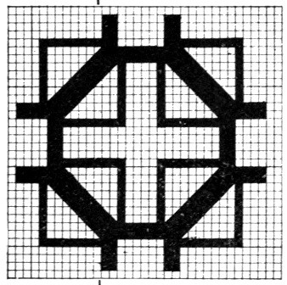 A rug pattern from a square
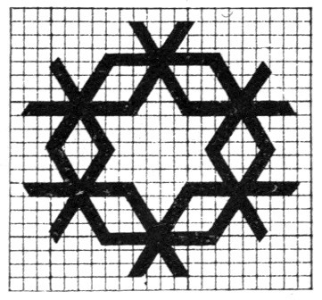 A rug pattern from an equilateral triangle

Fundamental form No. 2
The second fundamental form is made from a six-fold equilateral triangle. Directions[Pg 107] for folding and cutting this from the square are given in the "Paradise of Childhood." It can be cut, also, from a circle whose diameter is equal to the width of the rug desired. In drawing and cutting the pattern, hold the form with the entirely open sides toward you. The whole pattern is cut at once and the unfolding often reveals a charming design for a rug, which can be woven in tones or contrasting colors. If cut from colored paper, it can be mounted on white and placed under the warp. Beautiful original designs in conventional leaf and flower patterns can also be made.

Conventional leaf forms
To make a conventional leaf form, use fundamental form No. 1. Cut the leaf on the mid-rib and lay this part on the base of the triangle with the point of the leaf on the open edges at the left, and the stem on the closed part at the right. Draw around the edges of the leaf and cut, taking care not to separate the leaf forms at the center, which is at the closed part at your right hand.
Some excellent suggestions for this leaf-cutting in centerpieces and borders can be found in the "Pratt Institute Monthly" for April, 1900.

Dusters
Dusters for hardwood floors are best made of strips of old flannel. They can be[Pg 108] made of stocking strips, or cheese cloth. Make two mats the full size of the loom, sew on three sides and run a gathering-string around the top. It will fit better if it has a piece of cheese cloth sewn at the top through which the gathering-string can be run. This makes a fine duster to slip over a broom. If one prefers, a continuous warp can be strung—the length to be twice the length of the broom part—and a long piece woven which will require sewing on two sides only.
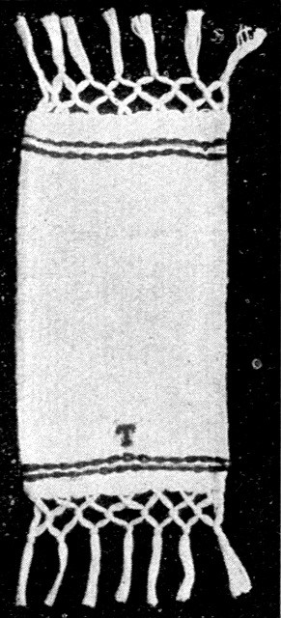 A doll towel with fringed ends

Doll towels

Patterns for towel borders

Lunch cloths

Bedspreads

Quilts
Doll towels are very fascinating things to make. Adjust the loom for the required size. The exact proportion can be ascertained from a large towel. String the close warp with fine darning cotton and have the strings in pairs with fringe at each end. Allow several inches for fringe so that it can be knotted easily. The woof threads, which are also of fine darning cotton, should be pushed very closely and smoothly together. Plain stripes of red or blue, or fancy stripes made with a kindergarten design, can be woven. Observe the same directions for spacing the stripes which are given with the silkoline rug.[Pg 109] The towel in the illustration is made of white darning cotton, with the stripes and initial of red. The children will be delighted to lay towel borders with their tablets, and after cutting and pasting with colored paper, weave them in towels for Miss Dolly's housekeeping. Cross-stitch the initial as previously directed. Lunch cloths and bedspreads can be made in the same way. These should be fringed all around. A cross-barred cloth or spread can be made by putting the color in the warp at regular intervals and weaving across with color and white to form squares. Pretty quilts of coarse cotton can be made with kindergarten designs. By weaving many squares, a large quilt can be made. See directions on page 50.

Bed and carriage blankets
Bed and carriage blankets are best made of single zephyr, although Germantown wool will do. The heavy carpet wools are also pretty. Some suggestions for this work have already been given under the head of Materials. These blankets are really mats, but made only for another use, and are to be woven in a similar way. Those with centers and borders are pretty, and the plaid ones are always attractive. (See illustration of the holder on page 92.)

Doll shawls
For doll shawls choose a pretty Scotch[Pg 110] plaid and match the colors in fine wool. String a close warp with wool, copying the Scotch plaid exactly. Weave the colors across so that a "truly" plaid shawl may grace Miss Dolly's shoulders on the cold winter mornings. A striped shawl is pretty, or one having one color for the center and another for the border.

Doll skirt
Miss Dolly may have a lovely petticoat, too. String a continuous warp long enough for the width of the skirt. Adjust the rods for the length. By using a little color in the warp near the right edge of the weaving, the skirt will have some stripes. Twist a cord of the wool and run in the top for a draw-string.

Reins
To make reins, adjust for a narrow strip and string a close, continuous warp the length desired. Make a piece, also, to go across the front. Use Germantown knitting yarn. A black warp with a bright red woof is pretty.

A square Tam O'Shanter
In order to obtain a Tam O'Shanter for Dolly, first weave a square the required size. String a close warp with wool and weave a kindergarten pattern with two colors. When completed, remove from the loom, fold four corners to the center, turn them in to form an opening for the head, and fasten[Pg 111] the edges by sewing, or by lacing with a cord made of the two colors. Fasten a tassel on the top and it is finished. Angora wool is pretty for these caps.
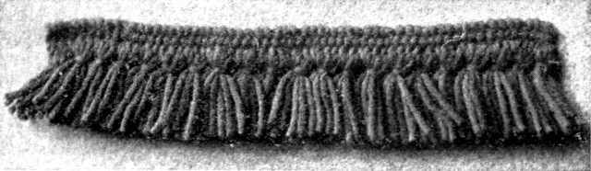 Fringe for a rug in red and black

Fringe

Threading the needle

Making the fringe into tassels

Removing the fringe from the loom
The head piece of the loom should be adjusted for the width of the rug for which the fringe is required. A rug nine inches wide would require fringe nine inches long. Adjust the rods one inch apart—that is, with one perforation between the rods. String the warp in every groove, one string over each rod and three between, making five in all. Weave over and under one until the heading is finished. If you have an extra side rod, place it in the sixth perforation from the right-hand rod. This will make tassels a little over two inches long. If a shorter fringe is preferred, adjust accordingly. If you have not an extra side rod remove the left one and place as directed, leaving the right one in the heading until the whole fringe is finished. Thread a large tape needle with two pieces of worsted, as[Pg 112] long as the two can be conveniently managed. If the fringe is made of two colors, take one of each for the tassels, weaving the heading with the one which predominates in the rug. Run the ends in the grooves to fasten them. Wind under the right rod, which was left in the heading, through the first stitch, which includes the warp string over the rod, then over the extra rod to the right. Wind under again through the next stitch in the heading (always around the rod) and so on until the end is reached. To make this fringe into tassels, separate six strands of each color and tie with the two colors, running the tape needle and worsted along from one tassel to another, or tie each one securely and cut. The fringe will need no finishing at the ends. Run the short ends, which were wound through the grooves in the beginning in order to fasten them, through a few stitches in the heading. The fringe can be made of one color, and of any width. To take the fringe from the loom, first remove the rod at the end of the tassels and cut the fringe before removing the rods from the heading. This will insure straight cutting at the ends of the tassels. If one prefers a knotted fringe, cut and knot before removing the heading. By examining rug[Pg 113] fringes in the furniture stores one can get a very good idea of the manner of knotting. (See also directions for splicing Germantown wool on page 84.)

Knotting
A simple fringe can be knotted quickly and easily in the ends of the warp strings, after the rug is taken from the loom. First decide upon the length of the fringe when finished. Add at least two inches to allow for knotting. Cut each piece of wool twice this length, double, and thread a tape needle. Pass the needle from the right side of the rug to the wrong, through the warp strings at the end of the rug. Draw the loop of wool through and unthread the needle. Pass the two ends of the wool down through the loop and draw it tight. When this has been done in every pair of warp strings, knot every other piece of the fringe together, in the same way that towel fringe is made.
This question of whether a rug should have fringe or not is much discussed at present. It is largely a personal one. The best way, perhaps, is to study different kinds of rugs and know which ones are usually made with fringe and which are not.
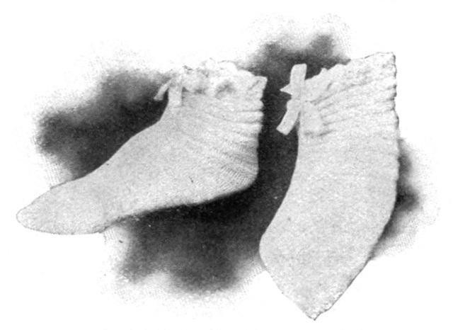 Bed shoes made of white wool

Bed shoes, or socks

Bed shoes

Baby shoes
Bed shoes of all sizes are easily woven, and make a useful holiday gift. They are made without soles and are intended to be[Pg 114] drawn up around the ankle like a high moccasin. Use the soft double Germantown wool. White, fastened together with pink or blue, or white striped with a color, may be used, and are attractive. The socks in the illustration are of white wool with a pink seam up the instep and pink scallops around the top. One sock is shown on a last, and the other as it appears off the foot. The stripes in the knitting can be shown in the weaving by using a color. The full size of the loom makes a shoe of medium size. String a close warp with white wool. If the shoe is to be all white, weave with the same, leaving the color for the finishing. If it is to be striped, weave perhaps eight or ten times across with color and then with white; when the weaving is finished you will have a mat 9 × 12 inches. Double one of the short edges and sew over and over on the wrong side with white wool. This is the toe. The two long edges now lie together. They may be crocheted, or knitted, with colored wool by holding them close and fulling in, or by[Pg 115] puckering a little. If this is done in color, it makes a pretty seam on the top of the foot and front of the ankle. The top may be finished by crocheting a beading and scallops of the colored wool. Run a ribbon or worsted cord through the beading. If desired, the long edges may be laced together with ribbon one-half inch wide. Baby shoes are made in the same way. To ascertain what length to adjust the loom, measure the sole, then up, back of the heel, to a point above the ankle. For the width, measure around the foot. Finish the cord with tassels or balls.

Worsted balls for bed shoes, and other articles
To make worsted balls, first cut two small circles from cardboard. From the center of each cut a smaller circle. Hold one circle over the other, and with a worsted or tape needle threaded with wool, wind over and over very closely until the hole in the center is completely filled. Always piece the wool on the outside edge. Cut the wool all around on the outside. Make a cord of the wool and slip between the two circles. Then tie so as to fasten all the pieces of wool in the middle, leaving the cord long enough to tie in a bow if desired. Tear the pasteboards, remove them, and trim the wool evenly. A second ball should be fastened on the other[Pg 116] end of the cord, after it has been laced through the beading.

Photograph frames
To weave photograph and picture frames of silk, chenille, raffia, celluloid, or leather, proceed in the same way as for a bordered rug, having the oblong or square center the required size for the picture. Foundation frames for mounting the work can be purchased, usually, at the stores where tissue paper and flowers are sold.

Table mats
Square and oblong table mats for hot dishes can be made of candle-wicking, knitting cotton, or cheese cloth.

Tippet or scarf
To-day, tippets and scarfs are very little used, but they are very comfortable things to wear to school on a cold day. In order to make them, string a continuous warp of the required length with Germantown dark colored wool. Weave the same color for the woof, and brighten it at intervals with Roman stripes. A plaid scarf can be woven, if preferred; while with a close warp one can have a kindergarten pattern in another, or contrasting color.

Wristlets
In making wristlets, one must decide how long they are to be, and adjust the length on the loom. Measure around the wrist for the width, remembering that the wristlets will stretch when pulled over the hand.[Pg 117] Weave in stripes or plaid, or, if desired, plain, stringing the warp with the same wool as is used in weaving. Remove the mat and sew the edges together.

Sleeve protectors
Sleeve protectors can be woven of raffia in the same way as wristlets. Make them so they can be fastened on the outside of the sleeve, like a cuff.
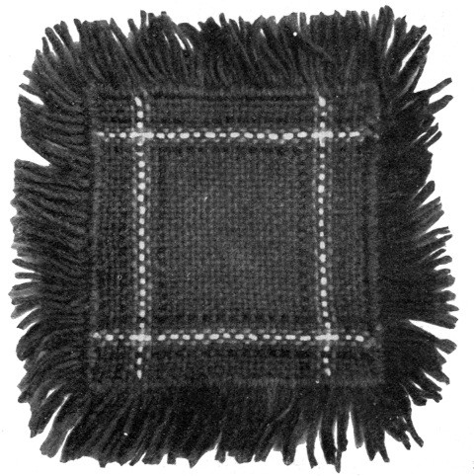 A table mat made from carpet wool
[Pg 118]

Purses, or chatelaine bags
Purses, or chatelaine bags, are made of knitting-silk. Beads can be added, if desired. Adjust the loom for the required size, and string a continuous warp, if necessary. One can obtain the silver or nickel tops, which open and close, at the department stores.
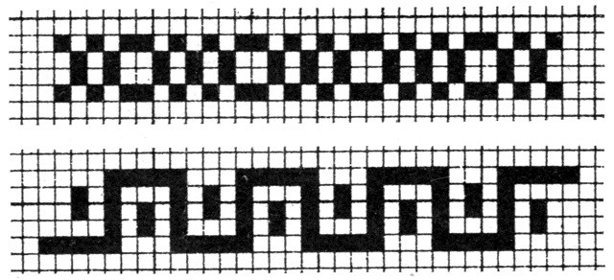 Borders for rugs or squares

Shopping and school bags

Opera glass bags
It will be better to use heavier material for shopping and school bags. Raffia makes a strong bag; silk strips are serviceable, and leather strips are good for school bags. For opera-glass bags, make two mats and lace or weave them together, or string a continuous warp. Use rope silk, chenille, or knitting silk with beads.
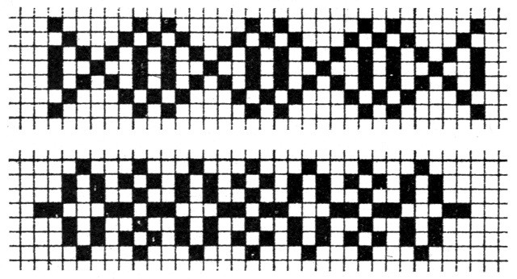 Borders for rugs or squares
[Pg 119]
When one has mastered the mysteries of weaving thoroughly enough to make a good mat, it is very easy to "turn them into" various articles. There is no sleight of hand about it.

Panels of silk canvas for boxes
Silk canvas panels are made by adjusting the loom for the required size of the sides of the box, and weaving a plain mat for the top. A number of suggestions have been given on page 52, under the head of Materials.
Pretty neckties of fine knitting silk can be made on the loom by using a continuous warp of the same material.
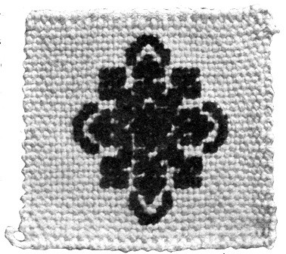 A square of silk canvas with cross-stitched pattern of chenille

Sofa pillows, cushions, sachet cases and veil cases
The accompanying illustration, and another on page 98, and also the vignette on the title page, show squares of silk canvas, and will give one many ideas of how they may be used. One has a cross-stitched pattern of chenille, and in another the chenille was alternated with silk in the warp, and[Pg 120] both chenille and silk were used in the woof. The squares can be made up in cushion and box covers, sachet cases, sofa pillows, or the larger squares can be used as veil cases. A number of them can be joined for large sofa pillows. In the latter case they can be made of wool, and many of them could be crocheted together for an afghan or slumber robe.
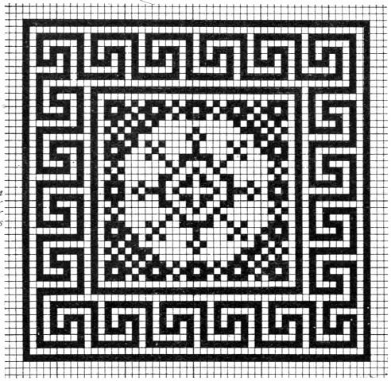 Pattern for rugs or squares
The design in the illustration is a pattern[Pg 121] which may be used for either a Wilton or Axminster rug, or for mats, sachet cases, cushion or box covers, or cross-stitch embroidery on burlap, or silk, or wool canvas. The patterns given on pages 120, 125, 130, and 134 will be found adaptable for rugs or squares.

Slumber robes or afghans

Portières
Slumber robes or afghans have been previously mentioned on page 54, under the head of Materials. It will be found very easy, after a little experience with a continuous warp, to make strips of any length. It is better to wind the extra lengths of warp upon spools, as has been suggested, or around the tops of the rods. Large portières can be made of long strips of silk or silkoline cut bias. Fasten the long strips together horizontally in imitation of Bagdad curtains.
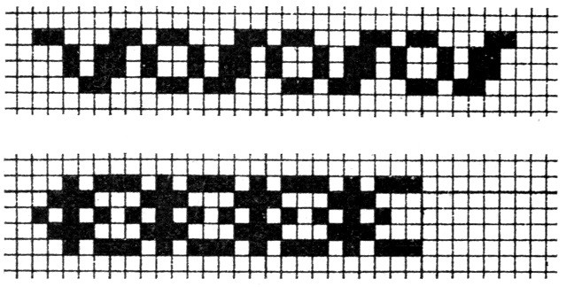 Borders for rugs or squares

Hair receivers
Hair receivers are easily made from raffia. Make a square mat and fold it in cornucopia form.

[Pg 122]

Chapter Twelve

ORIENTAL RUGS

Rugs and draperies
To be quite up to date, Miss Dolly should have oriental rugs and draperies in her house beautiful. These are easily made on the loom, and the little girl or boy, who has first copied a pattern and then seen it grow under patient fingers, has a thing of beauty and a joy forever. What could give more pleasure than to be able to say fifty years from now: "I wove that, my dear, when I went to school"? Truly the grandchildren would reply: "How I wish I could have gone to grandma's school!"—only they may have something equally beautiful which will take its place in that far-off time—who knows?
Border for rugs or squares
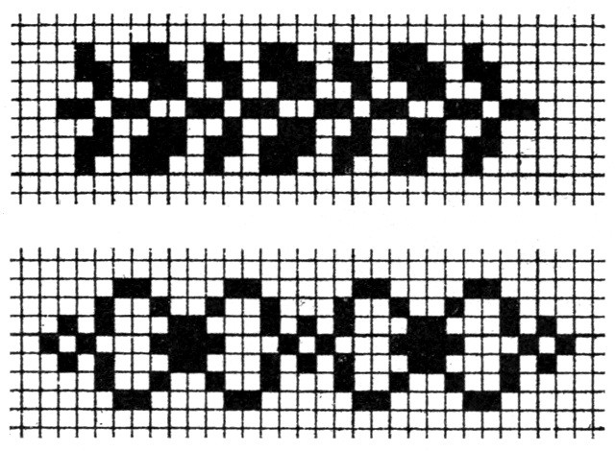 Borders for rugs or squares

Patterns

Oriental colors
The patterns for oriental rugs familiar in the East have descended through hundreds of years, and the exquisite colors, produced[Pg 123] by vegetable dyes, and increasing in richness and beauty with age, are only to be seen in old rugs. We have nothing in our modern dyes to compare with the old color. One is soon interested in the study of these Eastern treasures, and it becomes second nature in a short time not only to chat familiarly of Kermans, Serebends, Khivas, Bokharas, and Kiz-Kilims, ad infinitum, but to jot down now and then in one's notebook, or still better in one's design book (made of the kindergarten squared paper, one-eighth inch), a pretty border or centerpiece for the rug which is to grace some doll house. The patterns of Turkish rugs (see page 127) are of geometrical or arabesque designs—an[Pg 124] edict from the Koran having prohibited the reproduction of living things. The Persians, however, weave animals, birds, etc., as their ancestors did in days gone by.

Inscriptions on Persian rugs
There is some very interesting reading in "Oriental Rug Weaving," by V. Kurdji, on the subject of inscriptions often found on Persian rugs. He says: "If the possessors of some of the rare pieces that are sold in this country knew the meaning of the inscriptions woven in their rugs, the knowledge would add a charm and interest which would make them more valuable than the harmonious colors so beautifully blended."
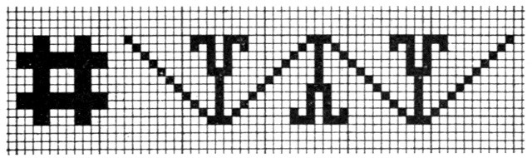 Pattern for border of Persian rug

Bokkara rugs

Khiva rugs
Oriental rugs take their names from the countries or provinces in which they are made. Bokhara rugs are made in mountainous districts of Turkestan, and have never been successfully imitated, because the dyes used are made from a plant grown only in that district. The designs are geometrical, and the colors deep maroon or blue. The pile is woven as close as velvet. They[Pg 125] are noted for the superior quality of their dyes. Khiva rugs, sometimes called afghan, are made in Turkestan. They resemble the Bokhara rugs, but are coarser in texture and heavier in pile, and they differ from them in having a wide selvage at each end. Some Khivas have a small pattern in red mosaic over the surface with a circle in the center. One often sees a rug made of a rich golden yellow with a background of dark red.
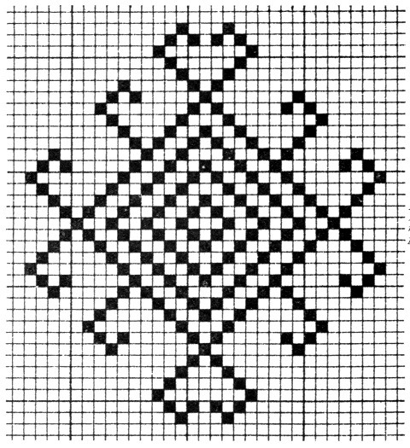 A Kiz-Kilim rug pattern
[Pg 126]
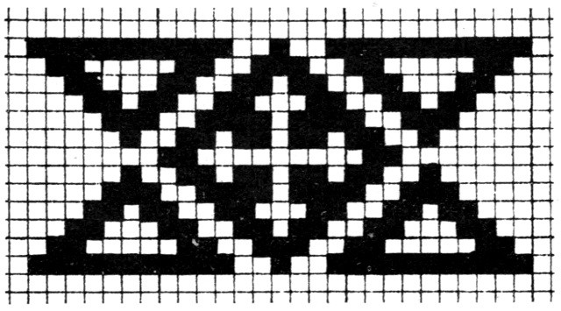 Pattern for a Kiz-Kilim stripe

Kiz-Kilim rugs

Kiz-Kilim rugs
The Kiz-Kilim rugs have no nap, and are woven with a needle. They are thin and almost alike on both sides. The larger sizes are woven in two strips fastened together so that they can be taken apart and used for curtains. "These Kiz-Kilims are woven by Armenians and Turks in Anatolia (the land of sunrise, and the Greek name for Asia Minor). The literal translation of the word Kiz-Kilim is bride's rug, it being a custom in that country for a bride to present to her husband one of these rugs, which she has woven during her engagement to him. The quality of the rug is supposed to measure the quality of the husband's affection for his bride, consequently we have many beautiful specimens of this class, the brilliant hues and intricate designs of which could only have been inspired by the whisperings of Cupid. They are in open-work patterns—called perforated—and often have long tufts of colored silk tied to the rugs with blue beads, in order to keep them from the effects of the Evil Eye." The Kiz-Kilim rug in the illustration was copied from a genuine rug. The filling is a deep blue and the borders are in oriental colors. The center figure is white, with red, brown, and yellow inside. There are four kinds of Kilims. Much interesting and valuable information can be found in John Kimberley Mumford's "Oriental Rugs"; New York: Charles Scribner's Sons, 1900, where directions for weaving Kiz-Kilims, Khivas, and Bokharas are given, with a few patterns.[Pg 127]
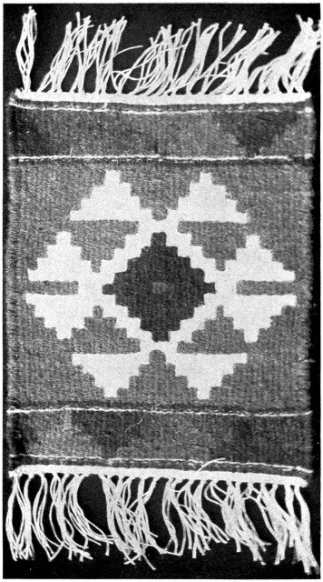 A Kiz-Kilim rug
[Pg 128]
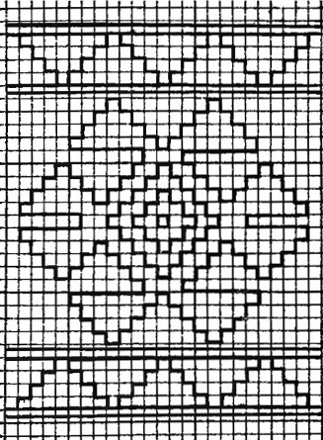 Pattern for a Turkish rug

Materials used

Perforations
Oriental wools or carpet ravelings are used for these rugs. Copy your figures and colors from genuine rugs. The accompanying patterns were obtained in this way. See directions on page 47 for stringing a double warp with fringe at each end. First fasten the pattern under the warp; then weave about one-quarter inch at each end with carpet thread like the warp. This will[Pg 129] make it look like a "truly" Kiz-Kilim. Next to this, weave a very narrow strip of several colors each twice across, regarding the double strings as one. Then weave each part of the narrow border. To make the perforations, take up one thread of the double warp for one side of the pattern, and the other thread for weaving the pattern next to it. For instance, the "steps," as the children call them, of triangle No. 1, when finished, will stand close to the steps of triangle No. 2, with a little slit between. These perforations occur only where one pattern joins another of a different color, or the dark filling. For instance, in the white figure in the center, where three or five squares come together, the slits occur at each end, the part between being woven over the double strings as if they were only one. In this way the perforations of other parts are closed top and bottom. Use a tape needle and weave each section of the pattern separately. Weave[Pg 130] the filling last. As this peculiar tone of blue could not be obtained in carpet ravelings, an eighth of a yard of terry was raveled for the purpose. Take care not to draw any part of the pattern too tight, or the perforations will be too large. The right and left edges of the rug are woven over the rods to keep them straight. Both narrow borders were woven before the center was commenced. The pattern in the illustration is for a Wilton or Axminster rug, but can be used for mats, or box, sachet, and cushion covers. It is made with cross-stitch embroidery on burlap, silk, or wool canvas. (See also page 120.)
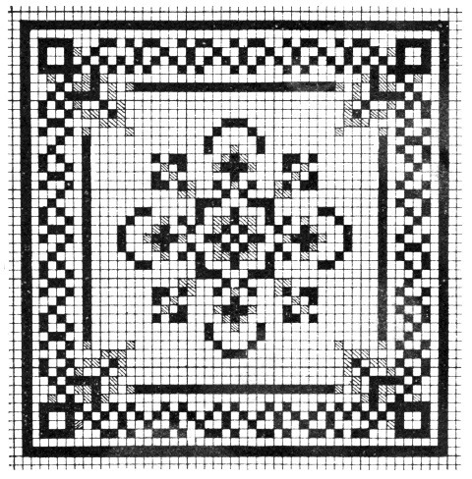 A pattern for a rug or square
[Pg 131]

Turkish patterns laid with tablets
The children can lay these Turkish patterns with square tablets upon their desks, the pattern being drawn upon the board, or on paper with a rubber pen. It will be a delight to the children to transfer them to paper by drawing and then coloring, or by cutting and pasting colored papers.

Stitches for Khiva and Bokhara rugs
The genuine Khiva and Bokhara rugs are made by weaving and knotting alternately. It will be easier at first to weave a web, or foundation. Choose a tight twisted yarn about the color of the rug to be woven. String a close warp of the wool and weave plain up and down, one string at a time, until you have a rug of the desired size. Put in the pattern first, and then the filling. This work will be almost too difficult for little children. Carpet wools and Germantown wool can be used. It will not be found difficult to follow the pattern, especially if one is used to cross-stitch embroidery. Each stitch counts for one of cross-stitch. Keep the stitches very close together so that the nap will stand up well when[Pg 132] finished. Silk rugs can be copied in the same way, using floss or rope silk for the pile. If one prefers, a piece of burlap may be stretched across the loom and secured to the rods, instead of weaving a foundation, as suggested.
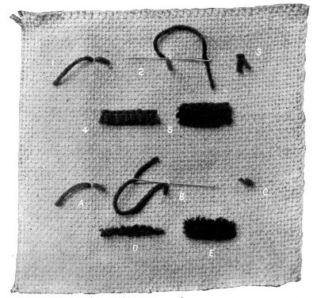 Stitches for pile weaving

Stitches for pile weaving

The first stitch
Stitches for pile weaving are very easily made. This illustration showing examples of stitches for pile weaving illustrates the methods used in the stitches, and may be used for Axminster or Wilton rugs, for boxes, sachet cases, and other articles. The tape[Pg 133] needle is the kind used for weaving when the large needle cannot be used. It is preferable to use one of this kind on account of the eye and blunt point, and it may be obtained at the notion counter in department stores for a few cents. There are two stitches, each occupying half of the illustration and numbered from left to right, beginning at the top. Make No. 1 by passing a tape needle threaded with wool down through the web, leaving a short end, then up one stitch to the left. This is the first step. In No. 2 continue over on the right side, past the stitch where you started, to the stitch on the right; then down and up through the first hole, and cut off the wool the same length as the end you left at first. No. 3 shows a stitch completed. No. 4, one row of stitches, and No. 5, three rows, showing how one row overlaps another. When the rug is finished, the ends should be cut evenly, so that the nap is like velvet. The children would say that this stitch looks like a two-legged stool, and so it does.

The second stitch
The second stitch is made so that the nap lies sideways from left to right. No. a is just like the preceding stitch. No. b shows the needle passing down the stitch where you started and up one stitch to the right.[Pg 134] Cut off the wool and pull the end left at first over the last one. This pile should stand very straight and even. No. c shows a completed stitch; No. d one row, and No. e three rows. These stitches are useful in mending Khiva and Bokhara rugs.

Wilton and Axminster rugs
Wilton, Axminster, or any rugs having a pile, can be woven with the same stitches. The pattern in the illustration may be used for either a Wilton or Axminster rug, for a box cover, cushion, sachet case, or mat; and can be cross-stitched embroidery, on burlap, silk or woolen canvas.
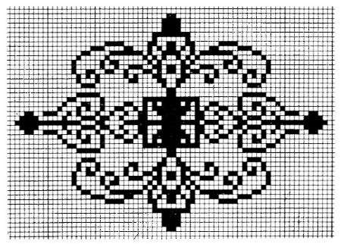 Pattern for a rug, mat or cover

[Pg 135]

Chapter Thirteen

NAVAJO BLANKETS
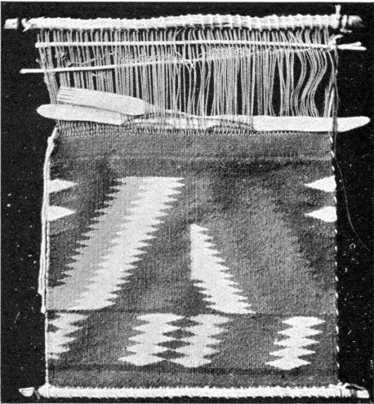 A miniature Indian loom

A sketch

Indian weaving

The colors used

Old Indian blankets are rare

Description of the illustration
Navajo blankets were first made by the Pueblo Indians, from whom the Navajo Indians learned the art, and not long after the latter excelled in the making of them. Among the Pueblo Indians the men do the work; but women are the weavers among the Navajos. In the illustration on this page is seen a miniature Navajo loom with the blanket commenced. The two cords woven at the sides with the woof can be easily seen. Simple looms are suspended between two posts or trees, and the weaver sits upon the ground. A twig is used for a shuttle, and a reed, fork-shaped[Pg 136] like a hand, is used to push down the woof threads. The blanket is made waterproof by pounding down the threads with a batten, a good picture of which is seen in Dr. Washington Matthews' article on Navajo weavers in the Third Annual Report of the Bureau of Ethnology. Separate balls of color are used to carry out the pattern, which is sometimes traced in the sand before the work is commenced. As many as twenty-nine different balls have been seen hanging from a single blanket. Some of the designs have been handed down from one generation to another, and are carried entirely in the memory. They are often symbolical "and unfold a whole legend to the knowing eye of the native." The weaving is done from the bottom up, some working in one direction, while others weave first at the bottom, then turn the loom upside down, and, after weaving about the same distance there, finish in the middle. The last part of the weaving is like darning, and is often done with a needle. The colors most used are white, gray, black, a bright yellow, red (a scarlet, generally obtained by raveling bayeta cloth), and sometimes blue. In former times, when the Indians used vegetable dyes, the colors were beautiful and lasting. These old blankets are becoming more and more rare, and to-day in their places we have the bright and not always satisfactory results of aniline dyes. The blanket in the illustration facing this page has narrow stripes in the following colors: On each end (seven stripes) red, black, white, orange, green, white, black. The two groups of six stripes in the middle are: Black, white, red, green, white, black. Before the advent of the present squaw dress, the black, red, and dark blue blankets were used as clothing, but the best blankets were, and still are, worn at sacred dances. Dr. Matthews, in his report, gives an interesting description of the method of making these blankets, with several pictures of the better examples. Navajo blankets are finished with four border cords, which are secured as the weaving progresses, and the ends are fastened at the four corners by small tassels.[Pg 137]
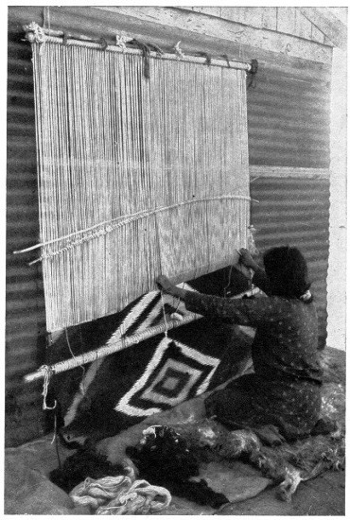 A Navajo Indian woman weaving a blanket
[Pg 138]

Method of making

Indian blankets
Small Navajo blankets can be woven on the loom. Draw the pattern and place under the warp, fastening it to the side rods. Use warp or carpet thread for the warp, and weave with a tape or upholstery needle. One may weave all the pattern first, and then put in the filling; while another will weave as the Indians do, filling in from one part of the pattern to the other by threading the needle with a different color. This can be done, without running the thread underneath, by hooking it in the loop of the pattern just finished. These little blankets are very fascinating things to make, and the children become much interested in them, and in Indian life as well.[Pg 139]
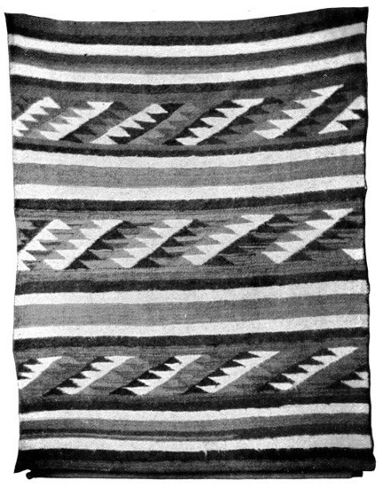 A Navajo blanket
[Pg 140]

The colors in the blanket on page 141
This very beautiful Navajo blanket, shown in the illustration, has three broad red stripes, two narrow red stripes about one-half the width of the former, and four gray stripes about one-half the width of narrow red stripes. The centers of all the figures are red, like the filling—a brilliant scarlet. The colors of the large figures, beginning at the center of each, and counting from left to right, are as follows: Nos. 1, 3, and 5, red, green, and light yellow. Nos. 2 and 4, red, white, and black. The small figures, counting the same way, are: Nos. 1, 3, and 5, red, white, and black. Nos. 2 and 4, red, yellow, and green. The four corners are finished with twisted red cord-like tassels. This cord also extends across the warp ends. Dr. Matthews tells in his article on "Navajo Weavers" how two cords are twisted and woven at the sides with the woof.[Pg 141]
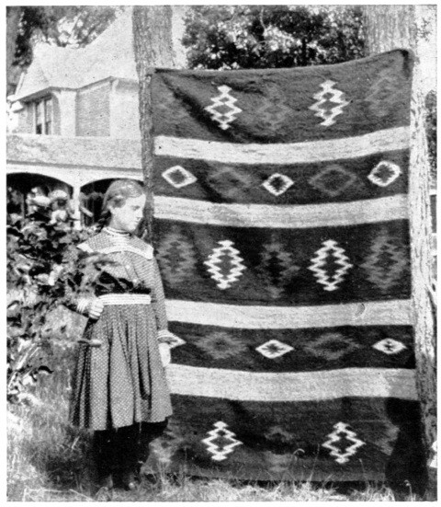 A very beautiful Navajo Indian blanket, showing the manner of decoration
The two Navajo Indian blankets illustrated in this chapter, and the pattern on the following page, may be easily adapted for the loom. Germantown knitting wool or carpet ravelings can be used, although to obtain softer wool is better. Some of the handsomest Navajo blankets have a long nap.[Pg 142]

Navajo patterns laid with tablets
The children will take pleasure in laying Navajo patterns with triangular tablets, and then transferring the pattern to paper by drawing and coloring, or by cutting and pasting in colors.
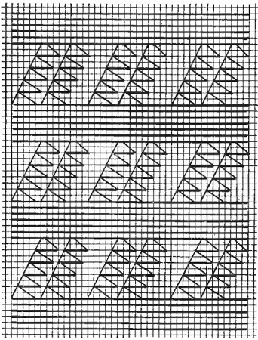 A pattern for a Navajo blanket

[Pg 143]

Chapter Fourteen

SONGS, GAMES, AND STORIES
There are many beautiful songs which can be sung during the weaving. Thomas Carlyle has said:

Songs and games lighten work
"Give us, O give us the man who sings at his work! He will do more in the same time; he will do it better; he will persevere longer. One is scarcely sensible of fatigue whilst he marches to music, and the very stars are said to make harmony as they revolve in their spheres."

Songs for the children
There are songs about the birds' nests, always pleasing to the little folks, and doubly so when they have held in their own hands the wonderful bit of weaving, so strong and yet so soft, woven by the mother-bird for the baby-birds. Mrs. Spider is also very interesting with her lace-like webs which are to be found even in well-regulated schoolrooms, and the songs of the bleating sheep who give us their wool fill every little heart with delight. Miss Poulsson's Finger Play, "The Lambs," gives the restless fingers something to do and the[Pg 144] "eight white sheep all fast asleep" afford a chance for a good laugh over the "two old dogs close by" (the thumbs). One has the opportunity, too, of noticing whether the eight white sheep on the tiny hands are really white enough to do the weaving. A smiling allusion to some small black sheep will bring them back clean for the next session.

A weaving game
The following weaving game can be played in several ways. This extract is from the "Kindergarten Guide," by Lois Bates: "Six children stand in a row; a tall one at each end for the border of the mat and the other four representing the strips. The child who is to be the weaver holds one end of a long tape, while the other is fastened to the left shoulder of the first child. The weaver weaves the tape in and out among the children, placing the second row lower down. It will be easily seen that the children who had it passed in front of them in the first row, had it behind them in the second, and vice versa."
The following weaving song in the Walker and Jenks book can be sung during the weaving. To be sure it is not really "over and under" when you think of them as children. Remember that they represent[Pg 145] a mat, and they are for the time the strips and border.
(Sung to the tune of "Nellie Bly.")
Over one, under one,
Over one again.
Under one, over one,
Then we do the same.
Hi, weavers! Ho, weavers!
Come and weave with me!
You'll rarely find, go where you will,
A happier band than we!
Kate Douglas Wiggin (Mrs. Riggs) in her "Republic of Childhood" describes the game in this way:

Explanation of the game
"First choose a row of children for threads of the warp, standing at such a distance from each other that a child may pass easily between them. Second, choose a child, or children, for thread of woof. After passing through the warp, each child takes his place at the end and other children are chosen." In this way more children can take part than if a tape were used. Some teachers play it in a different way, using the desks with the seats turned up for the warp and the whole number of children for the woof, winding in and out all over the room. This is very delightful, indeed, if there is enough space for the children to pass easily without tripping on the iron supports of the desks.[Pg 146] This is a good game for a rainy day, when there is no outdoor recess.

Bird games
The bird games are beautiful and leave a wholesome impression of home life and home love on the children, which will have a lasting influence. Few children, brought up in this tender and beautiful way, will ever feel an inclination to harm the birds, or indeed any animal.

Interesting stories
The fund of stories of birds and birds' nests is almost inexhaustible. Miss Poulsson's "In the Child's World" contains many stories of the weaver (pages 407-412), and several about birds and birds' nests (pages 292-301). Her talks to teachers with regard to the presentation of each subject are very helpful, as well as her suggestions for the teachers' reading. Stories of the weaving birds, particularly the African weaver, are interesting. It is said that two birds work together, one on the inside of the nest and the other on the outside, passing the grass and twigs in and out, until the home is completed. The children will enjoy, too, stories of weaving in other lands, material for which can be easily obtained. In fact, no one need to be without stories in these days of books and magazines.

Conversation

Never repress the children
Last, but not least, is the conversation[Pg 147] during the weaving. Anyone who has attended a teachers' meeting, where the industrial work was being given, has not failed to remark the sociability all over the room. "How are you getting on?" "Let me see yours." "Oh, I cannot get it at all," etc., etc., are heard everywhere, and yet those same teachers go into their class rooms the next day and expect the children to work without whispering. If they will read what Mrs. Wiggin says in the "Republic of Childhood," in her talk on "Sewing," they will never be guilty of it again. A good plan is to have the room perfectly quiet while a dictation is being given, and then allow a period of relaxation when the little folks can compare and admire the work to their hearts' content. Beware of too much repression. A child when asked why a tree grew crooked, replied: "Somebody stepped on it, I suppose, when it was a little fellow." The answer is painfully suggestive. Mrs. Wiggin truly says: "If the children are never to speak except when they answer questions, how are we to know aught of their inner life?"
The following list of songs, games, and stories suggests interesting material to correlate with the work in hand-loom weaving.[Pg 148]

SONGS AND GAMES

Songs and Games
Atkinson, Frank H., Jr. Singing Songs for Children. See Coonley.
Beebe, Katherine. Schoolroom Plays. Chicago: Thomas Charles Co. 25 cents.
A Weaving Game.
Brown, Kate L. Stories in Song. See Emerson.
Coolidge, Elizabeth. After Supper Songs. Chicago: Herbert S. Stone & Co. $2.00.
Coonley, Lydia A.; Smith, Eleanor; Gaynor, Jessie L.; Root, Frederick W.; and Atkinson, Frank H., Jr. Singing Verses for Children. New York: The Macmillan Co. $2.00.
Davis, Katherine Wallace. Singing Rhymes and Games. Chicago: Clayton T. Summy Co. 35 cents.
Emerson, Elizabeth U., and Brown, Kate L. Stories in Song. Boston: Oliver Ditson Co. $1.00.
The Oriole's Nest.
Forsythe, Clarence. Old Songs for Young America. New York: Doubleday, Page & Co. 1901. $2.00.
Needle's Eye.
Gaynor, Jessie L. Songs of the Child World. New York: The John Church Co. $1.00.
The Bird's Nest.
The Happy Lambkins.
Song of the Shearers.
Spinning the Yarn.
Grandma's Knitting Song.
Weaving Song.
[Pg 149]

Songs and Games
Gaynor, Jessie L. See also Coonley.
Hill, Patty S. Song Stories for the Kindergarten. Chicago: Clayton T. Summy Co. $1.00.
The Children and the Sheep.
Hofer, Mari Ruef. Children's Singing Games Chicago: Published by Mari Ruef Hofer, Kindergarten Magazine Co. 50 cents.
Hubbard, Clara Beeson. Merry Songs and Games. St. Louis: Balmer & Weber Music Co. $2.00.
Jenks, Harriet S. Songs and Games for Little Ones. See Walker.
Neidlinger, W. H. Small Songs for Small Singers. New York: G. Schirmer. $1.00.
The Spider.
The Bee.
The Rainy Day.
Nursery Stories and Rhymes for the Kindergarten and Home. Springfield, Mass.: Milton Bradley Co. $1.00.
The Song of a Baby's Blanket.
The Song of a Baby's Shirt.
Pratt, Waldo S. St. Nicholas Songs. New York: The Century Co. $2.00.
Root, Frederick W. Singing Songs for Children. See Coonley.
Smith, Eleanor. First Book in Vocal Music. Chicago and New York: Silver, Burdette & Co. 30 cents.
Oriole's Nest Song.
Spinning Song.
[Pg 150]

Songs and Games
Smith, Eleanor. A Primer of Vocal Music. Chicago and New York: Silver, Burdette & Co. 25 cents.
The Lazy Sheep.
The Spider.
The Silkworm.
---- See also Coonley.
Songs in Season. Plan Book. Chicago: A. Flanagan. 50 cents.
The Lambkin.
Walker, Gertrude, and Jenks, Harriet S. Songs and Games for Little Ones. Boston: Oliver Ditson Co. $1.50.
Birdies in the Green Wood.
Fly, Little Birds.
In the Branches of a Tree.
Eight White Sheep.
Weaving Song.

STORIES

Stories
Andrews, Jane. Each and All. Boston: Ginn & Co. 50 cents. Boston: Lee & Shepard. $1.00.
New Work for Pense.
Chase, A., and Clow, E. Stories of Industry. Boston: Educational Publishing Co. 2 vols. 60 cents each.
Stories of Cotton, Wool, Silk, and Carpets.
Clow, E. Stories of Industry. See Chase.
Farmer, Lydia Hoyt. Boy's Book of Famous Rulers. New York: Thomas Y. Crowell & Co. $1.50.
Robert Bruce and the Spider.
[Pg 151]

Stories
Miller, Olive Thorne. Little Folks in Feathers and Fur, and Others in Neither. New York: E. P. Dutton & Co. $2.50.
The Spider Speaks for Herself.
Stories of Caterpillars and Butterflies.
A Funny Little Log House.
Pierson, Clara Dillingham. Among the Farmyard People. New York: E. P. Dutton & Co. $1.25.
The Lamb with the Longest Tail.
The Twin Lambs.
Why the Sheep Ran Away.
Poulsson, Emilie. Nursery Finger Plays. Boston: Lothrop Publishing Co. $1.25.
The Lambs.
---- Child Stories and Rhymes. Boston: Lothrop Publishing Co. $1.25.
The Story of Baby's Blanket.
---- In the Child's World. Springfield, Mass.: Milton Bradley Co. $2.00.
Stories of Caterpillars and Butterflies.
A Visit to the Weaver.
John's Trousers.
How a Little Boy got a New Shirt.
Molly's Lamb.
Sequel to an Old Story.
Cotton Field Stories.
The Flax.
The Flax Flower.
The Silk Worm.
The Sparrow's Nest.
The Life of a Silk Worm.
The Goddess of the Silk Worm.
The Nest of Many Colors.
The Little Worm that was Glad to be Alive.
[Pg 152]

Stories
Smith, Nora A. The Story Hour. See Wiggin.
Stories in Season. Plan Book. Chicago: A. Flanagan. 35 cents.
The Bramble Bush and the Lambs.
Wiggin, Kate Douglas (Mrs. George C. Riggs), and Smith, Nora A. The Story Hour. Boston: Houghton, Mifflin & Co. $1.00.
The Child and the World.
Wiltse, Sara A. Kindergarten Stories and Morning Talks. Boston: Ginn & Co. 75 cents.
Stories of Wool, etc.

[Pg 153]

Chapter Fifteen

A LIST OF HELPFUL BOOKS AND MAGAZINE ARTICLES

BOOKS

Books
Albee, Mrs. Helen R. Abnákee Rugs. Boston: The Riverside Press. Issued by the author, Pequaket, Silver Lake P. O., N. H.
---- Mountain Playmates. Boston: Houghton, Mifflin & Co.
(Chapter on Rug-making.)
Ashenhurst, Thomas R. Designs in Textile Fabrics. London: Cassell & Co.
---- Weaving and Designing of Textile Fabrics. London: Simpkin, Marshall & Co.
(Chapters on History of Weaving, Color, and Combination and Arrangement of Designs.)
Bates, Lois. Kindergarten Guide. New York: Longmans, Green & Co.
Benjamin, S. G. W. Persia and the Persians. Boston: Houghton, Mifflin & Co.
Birdwood, Sir George. Industrial Arts of India. London: Chapman & Hall.
Bishop, Mrs. I. B. Journeys in Persia and Kurdistan. New York: G. P. Putnam's Sons.
Caine, William S. Picturesque India. New York: George Routledge & Sons.[Pg 154]

Books
Collins, Treachor E. In the Kingdom of the Shah. London: T. Fisher Unwin.
Davie, Oliver. Nests and Eggs of North American Birds. Columbus, Ohio: The Landon Press.
Dellenbaugh, Frederick S. North Americans of Yesterday. New York: G. P. Putnam's Sons.
Dixon, Charles. Curiosities in Bird Life. London: George Redway & Son.
---- Curious Nests. London: George Redway & Son.
Dugmore, A. Radclyffe. Bird Homes. New York: Doubleday, Page & Co.
Earle, Alice Morse. Home Life in Colonial Days. New York: The Macmillan Co.
Firth, Annie. Cane Basket Work. London: L. Upcott Gill. 1899. New York: Charles Scribner's Sons.
Grinnell, George Bird. Indians of To-day. New York: D. Appleton & Co.
---- Story of the Indian. New York: D. Appleton & Co.
Gurdji, V. Oriental Rug Weaving. New York: F. Tennyson Neely Co.
Herrick, Francis Hobart. The Home Life of the Wild Birds. New York: G. P. Putnam's Sons.
Holt, Rosa Belle. Rugs: Oriental and Occidental. Chicago: A. C. McClurg & Co.
How to Make and How to Mend. (Directions for dyeing.) New York: The Macmillan Co.
Hummel, Prof. The Dyeing of Textile Fabrics. New York: Cassell & Co.[Pg 155]

Books
James, George Wharton. Indian Basketry. New York: Henry Malkan. 1902.
Knapp, Elizabeth S. Raphia and Reed Weaving. Springfield, Mass.: Milton Bradley Co.
Kraus-Boelte, Mme. Kindergarten Guide. (Occupations.) New York: Steiger & Co.
Mason, O. T. Woman's Share in Primitive Culture. New York: D. Appleton & Co.
Morris, William. Some Hints on Pattern Designing. New York: Longmans, Green & Co.
Mumford, J. K. Oriental Rugs. New York: Charles Scribner's Sons.
Sheldon, William E., and others. Illustrated Lessons with Paper Folding. Springfield, Mass.: Milton Bradley Co.
Walker, Louisa. Varied Occupations in String Work; comprising Knotting, Netting, Looping, Plating, and Macremé. New York: The Macmillan Co.
---- Varied Occupations in Weaving. New York: The Macmillan Co.
Wheeler, Mrs. Candace. Home Industries and Domestic Weavings. New York: Associated Artists, 115 East 23d Street.
White, Mary. How to Make Baskets. New York: Doubleday, Page & Co. 1902.
Wiebe, Edward. Paradise of Childhood. Springfield, Mass.: Milton Bradley Co.
Wiggin, Kate Douglas (Mrs. George C. Riggs). Republic of Childhood (Occupations). Boston: Houghton, Mifflin & Co.
Worst, Edward F. Construction Work. Chicago: A. W. Mumford. 1901.[Pg 156]

FINE ART BOOKS

Fine art books
The following books can be found in the Fine Art Collections in some public libraries. They are very valuable and contain many very beautiful illustrations of oriental rugs and carpets, which are helpful in the study of design and of harmony in color:
Burty, P. Masterpieces of Industrial Art.
Coxon, Herbert. Oriental Carpets.
Lessing, Julius. Ancient Oriental Carpet Patterns.
Robinson, Vincent J. Eastern Carpets.
Vienna Imperial and Royal Austrian Museum. Oriental Carpets.

MAGAZINE ARTICLES

Magazine articles
A Profitable Philanthropy, by Mrs. Helen R. Albee. Review of Reviews, July, 1900.
Art of the American Indian. Chautauquan, March, 1899.
A Study of the Textile Art, by Wm. H. Holmes. Sixth Annual Report, Bureau of Ethnology, Washington, D. C. (pp. 84, 85.)
Domestic Art Number. Pratt Institute Monthly, February, 1901.
Home Industries and Domestic Manufactures, by Mrs. Candace Wheeler. The Outlook, Oct. 14, 1899.
Industrial Classes in Settlement Work, by George W. R. Twose. Pratt Institute Monthly, November, 1898.[Pg 157]

Magazine articles
Industrial Education as a Social Force, by H. W. Stebbins. Educational Review, May, 1902.
Juvenile Portiere Makers. New York Tribune, New York City, March 10, 1901. Reprinted in Minneapolis Journal Junior, April 20, 1901, Minneapolis, Minn.
Leaf Cutting (for rug designs). Pratt Institute Monthly, April, 1900.
Mrs. Volk and Her Work. Good Housekeeping, September, 1901.
Navajo Weavers, by Dr. Washington Matthews. Third Annual Report of Bureau of Ethnology, Washington, D. C.
(This volume also contains a number of fine illustrations of blankets, etc.)
New England Rugs. Minneapolis Journal, Minneapolis, Minn., March 28, 1900.
On the Designing and Making of Carpets, by F. J. Mayer. The Artist, July and August, 1899.
Prehistoric Textile Art of Eastern United States, by Wm. H. Holmes. Thirteenth Annual Report of Bureau of Ethnology, Washington, D. C. (pp. 91, 92.)
Some Social Aspects of Education, by G. Stanley Hall. Educational Review, May, 1902.
Straw Weaving. American Homes, Knoxville, Tenn., September, 1900.
Teachers' College Record. Teachers' College, Columbia University, New York.
(Containing a number of articles on weaving.)
[Pg 158]

Magazine articles
Textile Industries of the United States. Chautauquan, March, 1899.
Textile Industry Since 1890. Forum, May, 1899.
Textiles, Old and New. The Craftsman, The United Crafts, Eastwood, N. Y., January, 1902.
(Contains "Notes from the History of Textiles," "A Revival of English Handicrafts," and "Brain and Hand.")
The Elementary School Record, by Dr. John Dewey. Numbers 1 to 9. The University of Chicago Press, 1900.
(Containing a number of articles on weaving and a record of industrial work done in the University Elementary School of the University of Chicago.)
The Labor Museum at Hull House, by Jessie Luther. The Commons, Hull House, Chicago, Vol. VII., No. 70, May, 1902.
(Containing valuable illustrations of old looms, and the methods of spinning and weaving.)
Weavers of the Philippines, by G. E. Walsh. The Catholic World, March, 1902.
What is Being Done in Textile Education. Chautauquan, August, 1900.
Many topics interesting to teachers of industrial work are dealt with in the instruction papers of the International Correspondence Schools, Textile department. Communications should be addressed to Christopher P. Brooks, New Bedford, Mass.

[Pg 159]

The Index
"Abnákee Rug Industry," 63 ff.
Accuracy, weaving develops, 22.
Acids, used in dyeing, 69, 74 ff.
Action, relation to ideas, 8.
Afghans, weaving of, 49, 54, 120, 121.
Albee, Mrs. Helen R., 63, 64 ff.
Angora wool, 57.
Aniline dyes, 73.
Ashenhurst, quotations from, 13, 14, 16.
Axminster rugs, 120-121, 131, 132, 134.
Baby shoes, 115.
Balls, worsted, 115.
Basketry, preparation for, 23, 24.
Bates, Lois, 23, 31, 144.
Bath rugs, 100.
Batten, The, Hindoo and Egyptian, 15.
Bed shoes, 113, 114.
Bed spreads, 109.
Blankets, 56-57;
carriage, 109.
Blue dye, 59-60;
wool carded, 62.
Bokhara rugs, 123, 124-125, 128, 131, 134.
Bookmark, 35-36, 37.
Borders, 89, 109, 118, 121, 122, 123, 124.
Candle-wicking, 52, 83-84, 108.
Cap, 40.
Carding, 62 ff.
Carpet ravelings, see Ravelings.
Carpet wool, rugs of, 105.
Carriage blankets, 109.
Celluloid strips, 55-56, 85.
Chatelaine bags, 117-118.
Cheese cloth, 51, 58 ff., 99, 108.
Chenille, 42, 53;
splicing of, 83-84.
Chinese, weaving practiced by, 13.
Clavigero, on weaving in Mexico, 14.
Clouding, 63.
Coles, C. S., 24.
Colors, 62, 64-65, 136-138;
color scheme, 66;
shading, 67-68;
see also Dyes, Formulas, and names of colors.
Concentration, weaving develops, 22.
Conversation in class room, 147.
Copperas, 60.
Cotton, darning, 55;
knitting, 55.
Couch covers, weaving of, 49.
Creed, The, 7;
disregarded, 7-8.
Cushions, 120.
Demonstration cards, 31.
Designing, weaving prepares for, 23, 25.
Designs, 27, 31, 33, 35, 47-48, 57, 105 ff., 120, 122.
Dexterity, weaving develops, 22, 24.
Discouragement, Froebel's theory, 17.
Dish cloths, 99-100.
Doll's shawl and skirt, 109-110.
Doll's towel, 55, 108-109.
Dusters, 107-108.
Dyeing, 14, 58-82;
formulas, 73 ff.
Dyes, kinds of, 58, 60, 61, 72, 73;
see also names of colors.
Easel support for loom, 19.
Egyptians, inventors of the loom, 14.
Face cloths, 99-100.
Felt mats, 23, 30-32.
Finger Play, 143.
Floor rugs, weaving of, 49-50.
Formulas for colors, 73 ff.
Frames, photograph and picture, 116.
Free-paper weaving, 35.
Fringe, 111-113.
Froebel, Friedrich, 10, 17.
Games, 143-152;
list of, 148 ff.
Germantown wool, 54, 55, 84, 109, 114.
Gifts, made by children, 21, 34, 37, 55, 113.
Glauber salts, 68, 69, 71, 74 ff.
Glove boxes, 104.
Gray, wool carded, 62-63.
Green dye, 66;
dull shade, 69.
Hair receivers, 121.
Hammocks, 93-98.
Hand-training in kindergarten, 10, 22.
Hindoo loom, 15-16.
Holders, 91, 92.
Hurwitz, Professor, 13.
Indian dyes, 58.
Indian loom, 135, 137.
Individual, The, training of, 28.
Industrial training, 11, 28-29.
Ink stains, 61.
Iron rust, 61.
"Jacob's ladder," 39.
Kerman rugs, 123.
Khiva rugs, 123, 125, 128, 131, 134.
Kindergarten, hand-training in, 10.
"Kindergarten Guides," 23, 31, 33, 144.
Kiz-Kilim rugs, 47, 123, 125, 126-129.
Knotting fringe, 113.
[Pg 160]Kraus-Boelte, Mme., 25.
"Kraus-Boelte Guide," 25.
Kurdji, V., 124.
Leaf forms, 107.
Leaf stains, 61.
Leather strips, 55, 85.
Linings, 51.
Loom, The, 13-21.
Loom, The Todd Adjustable Hand, see Todd.
Lunch cloths, 109.
Macremé cord, 55;
splicing of, 83-84.
Making, instinct for, 9.
Manual training, 10.
Materials, 10, 51-57.
Mats, see Felt, Paper, and Table.
Matthews, Dr. W., 58, 136, 138, 140.
Measuring glass, 68-69.
Mill, John Stuart, 8.
Mitten, 40.
Mordants, 68.
Mottled rugs and borders, 87 ff.
Mumford, John Kimberley, 128.
Navajo blankets, 48, 135-142.
Needle, used with loom, 19, 20.
Nut stains, 60-61.
Opera-glass bags, 118.
Oriental cord, for warp, 43.
Oriental rugs, weaving of, 122-134.
"Oriental Rugs," 128.
"Oriental Rug Weaving," 124.
Panels, of silk canvas, 119.
Paper mats, 23, 25, 33 ff.
"Paradise of Childhood," 35, 105, 107.
Patterns, see Designs.
Pencil holder, 38.
Persian rugs, designs for, 124.
Photograph and picture frames, 116.
Pile weaving, 132-134.
Pink, wool carded, 62.
Porch curtains, 104.
Portières, 121.
Poulsson, Miss, 143, 146.
Practical training, need of, 10.
Principles, value of learning, 23.
Public schools, practical training in, 10, 18, 26-27.
Purses, 117-118.
"Pussy-cat stairs," 39-40.
Quilts, 109.
Raffia, 42, 45, 56, 58 ff., 71, 84-85.
Raffia mats, method of weaving, 101-121.
Ravelings, 43, 53, 83.
Red dye, 60.
Reins, 110.
"Republic of Childhood," The, 34, 145.
Rope silk, 42, 52-53;
splicing of, 84.
Sachet cases, 120.
Scarf, 116.
School bags, 118.
Scientific facts as applied in schools, 8.
Sequence weaving, 35 ff.
Serebend rugs, 123.
Shawls, 109-110.
Shetland wool, 56.
Shoes, bed, 113-114;
baby, 115.
Shopping bags, 118.
Shuttle, Egyptian, 13;
Hindoo, 15.
Silk, 52;
knitting, 57.
Silk canvas, 119-120.
Silkoline, 51, 83;
for rugs or mats, 86-92.
Skirt, doll's, 110.
Slats, weaving with, 23-24, 31-32.
Sleeve protectors, 117.
Slumber robes, 49, 54, 120, 121.
Socks, 113-114.
Sofa pillows, 120.
Songs, games, and stories, 143-152, 148 ff.
Splicing, methods of, 83-85.
Splints, weaving with, 23-24, 39.
Star, 37.
Steiger, E., publisher, 35.
Stories, 143, 152;
list of, 148 ff.
"Straw Weaving," 104.
Success, Froebel's theory, 17.
Sweater, doll's, 41.
Table cover, 49.
Table mats, 38, 116, 117.
Tam O'Shanter, 110.
Tassels, 112.
Tippet, 116.
Todd Adjustable Hand-loom, 18-21.
Towels, doll's, 55, 108-109.
Turkish rugs, designs for, 47-48, 123-124.
Vegetable dyes, 58, 61, 72.
Vegetable fibres, for weaving, 13, 14.
Veil cases, 120.
Walker and Jenks, song by, 144, 145.
Warp, 20, 42-50.
Weaving, its advantages, 11, 22;
oldest of the industrial arts, 12, 13, 14;
defined, 22;
first steps in, 23, 30-41;
free paper, 35.
Wheeler, Mrs. Candace, 58.
Wiebe, Edward, 34, 35.
Wiggin, Mrs. Kate Douglas, 34, 145.
Wilton rugs, 120-121, 131, 132, 134.
Woof, stringing of, 20.
Wool, for weaving, 13, 14, 54, 62 ff.
Worsted, splicing of, 83.
Wristlets, 116-117.

***END OF THE PROJECT GUTENBERG EBOOK HAND-LOOM WEAVING***
******* This file should be named 31630-h.txt or 31630-h.zip *******
This and all associated files of various formats will be found in:
http://www.gutenberg.org/3/1/6/3/31630
Updated editions will replace the previous one--the old editions will be renamed.
Creating the works from public domain print editions means that no one owns a United States copyright in these works, so the Foundation (and you!) can copy and distribute it in the United States without permission and without paying copyright royalties. Special rules, set forth in the General Terms of Use part of this license, apply to copying and distributing Project Gutenberg-tm electronic works to protect the PROJECT GUTENBERG-tm concept and trademark. Project Gutenberg is a registered trademark, and may not be used if you charge for the eBooks, unless you receive specific permission. If you do not charge anything for copies of this eBook, complying with the rules is very easy. You may use this eBook for nearly any purpose such as creation of derivative works, reports, performances and research. They may be modified and printed and given away--you may do practically ANYTHING with public domain eBooks. Redistribution is subject to the trademark license, especially commercial redistribution.
*** START: FULL LICENSE ***
THE FULL PROJECT GUTENBERG LICENSE
PLEASE READ THIS BEFORE YOU DISTRIBUTE OR USE THIS WORK
To protect the Project Gutenberg-tm mission of promoting the free
distribution of electronic works, by using or distributing this work
(or any other work associated in any way with the phrase "Project
Gutenberg"), you agree to comply with all the terms of the Full Project
Gutenberg-tm License (available with this file or online at
http://www.gutenberg.org/license).
Section 1. General Terms of Use and Redistributing Project Gutenberg-tm
electronic works
1.A. By reading or using any part of this Project Gutenberg-tm
electronic work, you indicate that you have read, understand, agree to
and accept all the terms of this license and intellectual property
(trademark/copyright) agreement. If you do not agree to abide by all
the terms of this agreement, you must cease using and return or destroy
all copies of Project Gutenberg-tm electronic works in your possession.
If you paid a fee for obtaining a copy of or access to a Project
Gutenberg-tm electronic work and you do not agree to be bound by the
terms of this agreement, you may obtain a refund from the person or
entity to whom you paid the fee as set forth in paragraph 1.E.8.
1.B. "Project Gutenberg" is a registered trademark. It may only be
used on or associated in any way with an electronic work by people who
agree to be bound by the terms of this agreement. There are a few
things that you can do with most Project Gutenberg-tm electronic works
even without complying with the full terms of this agreement. See
paragraph 1.C below. There are a lot of things you can do with Project
Gutenberg-tm electronic works if you follow the terms of this agreement
and help preserve free future access to Project Gutenberg-tm electronic
works. See paragraph 1.E below.
1.C. The Project Gutenberg Literary Archive Foundation ("the Foundation"
or PGLAF), owns a compilation copyright in the collection of Project
Gutenberg-tm electronic works. Nearly all the individual works in the
collection are in the public domain in the United States. If an
individual work is in the public domain in the United States and you are
located in the United States, we do not claim a right to prevent you from
copying, distributing, performing, displaying or creating derivative
works based on the work as long as all references to Project Gutenberg
are removed. Of course, we hope that you will support the Project
Gutenberg-tm mission of promoting free access to electronic works by
freely sharing Project Gutenberg-tm works in compliance with the terms of
this agreement for keeping the Project Gutenberg-tm name associated with
the work. You can easily comply with the terms of this agreement by
keeping this work in the same format with its attached full Project
Gutenberg-tm License when you share it without charge with others.
1.D. The copyright laws of the place where you are located also govern
what you can do with this work. Copyright laws in most countries are in
a constant state of change. If you are outside the United States, check
the laws of your country in addition to the terms of this agreement
before downloading, copying, displaying, performing, distributing or
creating derivative works based on this work or any other Project
Gutenberg-tm work. The Foundation makes no representations concerning
the copyright status of any work in any country outside the United
States.
1.E. Unless you have removed all references to Project Gutenberg:
1.E.1. The following sentence, with active links to, or other immediate
access to, the full Project Gutenberg-tm License must appear prominently
whenever any copy of a Project Gutenberg-tm work (any work on which the
phrase "Project Gutenberg" appears, or with which the phrase "Project
Gutenberg" is associated) is accessed, displayed, performed, viewed,
copied or distributed:
This eBook is for the use of anyone anywhere at no cost and with
almost no restrictions whatsoever. You may copy it, give it away or
re-use it under the terms of the Project Gutenberg License included
with this eBook or online at www.gutenberg.org
1.E.2. If an individual Project Gutenberg-tm electronic work is derived
from the public domain (does not contain a notice indicating that it is
posted with permission of the copyright holder), the work can be copied
and distributed to anyone in the United States without paying any fees
or charges. If you are redistributing or providing access to a work
with the phrase "Project Gutenberg" associated with or appearing on the
work, you must comply either with the requirements of paragraphs 1.E.1
through 1.E.7 or obtain permission for the use of the work and the
Project Gutenberg-tm trademark as set forth in paragraphs 1.E.8 or
1.E.9.
1.E.3. If an individual Project Gutenberg-tm electronic work is posted
with the permission of the copyright holder, your use and distribution
must comply with both paragraphs 1.E.1 through 1.E.7 and any additional
terms imposed by the copyright holder. Additional terms will be linked
to the Project Gutenberg-tm License for all works posted with the
permission of the copyright holder found at the beginning of this work.
1.E.4. Do not unlink or detach or remove the full Project Gutenberg-tm
License terms from this work, or any files containing a part of this
work or any other work associated with Project Gutenberg-tm.
1.E.5. Do not copy, display, perform, distribute or redistribute this
electronic work, or any part of this electronic work, without
prominently displaying the sentence set forth in paragraph 1.E.1 with
active links or immediate access to the full terms of the Project
Gutenberg-tm License.
1.E.6. You may convert to and distribute this work in any binary,
compressed, marked up, nonproprietary or proprietary form, including any
word processing or hypertext form. However, if you provide access to or
distribute copies of a Project Gutenberg-tm work in a format other than
"Plain Vanilla ASCII" or other format used in the official version
posted on the official Project Gutenberg-tm web site (www.gutenberg.org),
you must, at no additional cost, fee or expense to the user, provide a
copy, a means of exporting a copy, or a means of obtaining a copy upon
request, of the work in its original "Plain Vanilla ASCII" or other
form. Any alternate format must include the full Project Gutenberg-tm
License as specified in paragraph 1.E.1.
1.E.7. Do not charge a fee for access to, viewing, displaying,
performing, copying or distributing any Project Gutenberg-tm works
unless you comply with paragraph 1.E.8 or 1.E.9.
1.E.8. You may charge a reasonable fee for copies of or providing
access to or distributing Project Gutenberg-tm electronic works provided
that
- You pay a royalty fee of 20% of the gross profits you derive from
the use of Project Gutenberg-tm works calculated using the method
you already use to calculate your applicable taxes. The fee is
owed to the owner of the Project Gutenberg-tm trademark, but he
has agreed to donate royalties under this paragraph to the
Project Gutenberg Literary Archive Foundation. Royalty payments
must be paid within 60 days following each date on which you
prepare (or are legally required to prepare) your periodic tax
returns. Royalty payments should be clearly marked as such and
sent to the Project Gutenberg Literary Archive Foundation at the
address specified in Section 4, "Information about donations to
the Project Gutenberg Literary Archive Foundation."
- You provide a full refund of any money paid by a user who notifies
you in writing (or by e-mail) within 30 days of receipt that s/he
does not agree to the terms of the full Project Gutenberg-tm
License. You must require such a user to return or
destroy all copies of the works possessed in a physical medium
and discontinue all use of and all access to other copies of
Project Gutenberg-tm works.
- You provide, in accordance with paragraph 1.F.3, a full refund of any
money paid for a work or a replacement copy, if a defect in the
electronic work is discovered and reported to you within 90 days
of receipt of the work.
- You comply with all other terms of this agreement for free
distribution of Project Gutenberg-tm works.
1.E.9. If you wish to charge a fee or distribute a Project Gutenberg-tm
electronic work or group of works on different terms than are set
forth in this agreement, you must obtain permission in writing from
both the Project Gutenberg Literary Archive Foundation and Michael
Hart, the owner of the Project Gutenberg-tm trademark. Contact the
Foundation as set forth in Section 3 below.
1.F.
1.F.1. Project Gutenberg volunteers and employees expend considerable
effort to identify, do copyright research on, transcribe and proofread
public domain works in creating the Project Gutenberg-tm
collection. Despite these efforts, Project Gutenberg-tm electronic
works, and the medium on which they may be stored, may contain
"Defects," such as, but not limited to, incomplete, inaccurate or
corrupt data, transcription errors, a copyright or other intellectual
property infringement, a defective or damaged disk or other medium, a
computer virus, or computer codes that damage or cannot be read by
your equipment.
1.F.2. LIMITED WARRANTY, DISCLAIMER OF DAMAGES - Except for the "Right
of Replacement or Refund" described in paragraph 1.F.3, the Project
Gutenberg Literary Archive Foundation, the owner of the Project
Gutenberg-tm trademark, and any other party distributing a Project
Gutenberg-tm electronic work under this agreement, disclaim all
liability to you for damages, costs and expenses, including legal
fees. YOU AGREE THAT YOU HAVE NO REMEDIES FOR NEGLIGENCE, STRICT
LIABILITY, BREACH OF WARRANTY OR BREACH OF CONTRACT EXCEPT THOSE
PROVIDED IN PARAGRAPH F3. YOU AGREE THAT THE FOUNDATION, THE
TRADEMARK OWNER, AND ANY DISTRIBUTOR UNDER THIS AGREEMENT WILL NOT BE
LIABLE TO YOU FOR ACTUAL, DIRECT, INDIRECT, CONSEQUENTIAL, PUNITIVE OR
INCIDENTAL DAMAGES EVEN IF YOU GIVE NOTICE OF THE POSSIBILITY OF SUCH
DAMAGE.
1.F.3. LIMITED RIGHT OF REPLACEMENT OR REFUND - If you discover a
defect in this electronic work within 90 days of receiving it, you can
receive a refund of the money (if any) you paid for it by sending a
written explanation to the person you received the work from. If you
received the work on a physical medium, you must return the medium with
your written explanation. The person or entity that provided you with
the defective work may elect to provide a replacement copy in lieu of a
refund. If you received the work electronically, the person or entity
providing it to you may choose to give you a second opportunity to
receive the work electronically in lieu of a refund. If the second copy
is also defective, you may demand a refund in writing without further
opportunities to fix the problem.
1.F.4. Except for the limited right of replacement or refund set forth
in paragraph 1.F.3, this work is provided to you 'AS-IS,' WITH NO OTHER
WARRANTIES OF ANY KIND, EXPRESS OR IMPLIED, INCLUDING BUT NOT LIMITED TO
WARRANTIES OF MERCHANTIBILITY OR FITNESS FOR ANY PURPOSE.
1.F.5. Some states do not allow disclaimers of certain implied
warranties or the exclusion or limitation of certain types of damages.
If any disclaimer or limitation set forth in this agreement violates the
law of the state applicable to this agreement, the agreement shall be
interpreted to make the maximum disclaimer or limitation permitted by
the applicable state law. The invalidity or unenforceability of any
provision of this agreement shall not void the remaining provisions.
1.F.6. INDEMNITY - You agree to indemnify and hold the Foundation, the
trademark owner, any agent or employee of the Foundation, anyone
providing copies of Project Gutenberg-tm electronic works in accordance
with this agreement, and any volunteers associated with the production,
promotion and distribution of Project Gutenberg-tm electronic works,
harmless from all liability, costs and expenses, including legal fees,
that arise directly or indirectly from any of the following which you do
or cause to occur: (a) distribution of this or any Project Gutenberg-tm
work, (b) alteration, modification, or additions or deletions to any
Project Gutenberg-tm work, and (c) any Defect you cause.
Section 2. Information about the Mission of Project Gutenberg-tm
Project Gutenberg-tm is synonymous with the free distribution of
electronic works in formats readable by the widest variety of computers
including obsolete, old, middle-aged and new computers. It exists
because of the efforts of hundreds of volunteers and donations from
people in all walks of life.
Volunteers and financial support to provide volunteers with the
assistance they need are critical to reaching Project Gutenberg-tm's
goals and ensuring that the Project Gutenberg-tm collection will
remain freely available for generations to come. In 2001, the Project
Gutenberg Literary Archive Foundation was created to provide a secure
and permanent future for Project Gutenberg-tm and future generations.
To learn more about the Project Gutenberg Literary Archive Foundation
and how your efforts and donations can help, see Sections 3 and 4
and the Foundation web page at http://www.gutenberg.org/fundraising/pglaf.
Section 3. Information about the Project Gutenberg Literary Archive
Foundation
The Project Gutenberg Literary Archive Foundation is a non profit
501(c)(3) educational corporation organized under the laws of the
state of Mississippi and granted tax exempt status by the Internal
Revenue Service. The Foundation's EIN or federal tax identification
number is 64-6221541. Contributions to the Project Gutenberg
Literary Archive Foundation are tax deductible to the full extent
permitted by U.S. federal laws and your state's laws.
The Foundation's principal office is located at 4557 Melan Dr. S.
Fairbanks, AK, 99712., but its volunteers and employees are scattered
throughout numerous locations. Its business office is located at
809 North 1500 West, Salt Lake City, UT 84116, (801) 596-1887, email
business@pglaf.org. Email contact links and up to date contact
information can be found at the Foundation's web site and official
page at http://www.gutenberg.org/about/contact
For additional contact information:
Dr. Gregory B. Newby
Chief Executive and Director
gbnewby@pglaf.org
Section 4. Information about Donations to the Project Gutenberg
Literary Archive Foundation
Project Gutenberg-tm depends upon and cannot survive without wide
spread public support and donations to carry out its mission of
increasing the number of public domain and licensed works that can be
freely distributed in machine readable form accessible by the widest
array of equipment including outdated equipment. Many small donations
($1 to $5,000) are particularly important to maintaining tax exempt
status with the IRS.
The Foundation is committed to complying with the laws regulating
charities and charitable donations in all 50 states of the United
States. Compliance requirements are not uniform and it takes a
considerable effort, much paperwork and many fees to meet and keep up
with these requirements. We do not solicit donations in locations
where we have not received written confirmation of compliance. To
SEND DONATIONS or determine the status of compliance for any
particular state visit http://www.gutenberg.org/fundraising/pglaf
While we cannot and do not solicit contributions from states where we
have not met the solicitation requirements, we know of no prohibition
against accepting unsolicited donations from donors in such states who
approach us with offers to donate.
International donations are gratefully accepted, but we cannot make
any statements concerning tax treatment of donations received from
outside the United States. U.S. laws alone swamp our small staff.
Please check the Project Gutenberg Web pages for current donation
methods and addresses. Donations are accepted in a number of other
ways including checks, online payments and credit card donations.
To donate, please visit: http://www.gutenberg.org/fundraising/donate
Section 5. General Information About Project Gutenberg-tm electronic
works.
Professor Michael S. Hart is the originator of the Project Gutenberg-tm
concept of a library of electronic works that could be freely shared
with anyone. For thirty years, he produced and distributed Project
Gutenberg-tm eBooks with only a loose network of volunteer support.
Project Gutenberg-tm eBooks are often created from several printed
editions, all of which are confirmed as Public Domain in the U.S.
unless a copyright notice is included. Thus, we do not necessarily
keep eBooks in compliance with any particular paper edition.
Each eBook is in a subdirectory of the same number as the eBook's
eBook number, often in several formats including plain vanilla ASCII,
compressed (zipped), HTML and others.
Corrected EDITIONS of our eBooks replace the old file and take over
the old filename and etext number. The replaced older file is renamed.
VERSIONS based on separate sources are treated as new eBooks receiving
new filenames and etext numbers.
Most people start at our Web site which has the main PG search facility:
http://www.gutenberg.org
This Web site includes information about Project Gutenberg-tm,
including how to make donations to the Project Gutenberg Literary
Archive Foundation, how to help produce our new eBooks, and how to
subscribe to our email newsletter to hear about new eBooks.
EBooks posted prior to November 2003, with eBook numbers BELOW #10000,
are filed in directories based on their release date. If you want to
download any of these eBooks directly, rather than using the regular
search system you may utilize the following addresses and just
download by the etext year.
http://www.gutenberg.org/dirs/etext06/
(Or /etext 05, 04, 03, 02, 01, 00, 99,
98, 97, 96, 95, 94, 93, 92, 92, 91 or 90)
EBooks posted since November 2003, with etext numbers OVER #10000, are
filed in a different way. The year of a release date is no longer part
of the directory path. The path is based on the etext number (which is
identical to the filename). The path to the file is made up of single
digits corresponding to all but the last digit in the filename. For
example an eBook of filename 10234 would be found at:
http://www.gutenberg.org/dirs/1/0/2/3/10234
or filename 24689 would be found at:
http://www.gutenberg.org/dirs/2/4/6/8/24689
An alternative method of locating eBooks:
http://www.gutenberg.org/dirs/GUTINDEX.ALL
*** END: FULL LICENSE ***

